**FINAL PROJECT REPORT**

**ABOUT**

**STAFF RESTAURANT**

**AL AZHAR RIZQI RIFA’I FIRDAUS**

**1I**



**POLITEKNIK NEGERI MALANG**

**DECEMBER 2022**

**1.1 Flowchart**

* **Function displayHome**

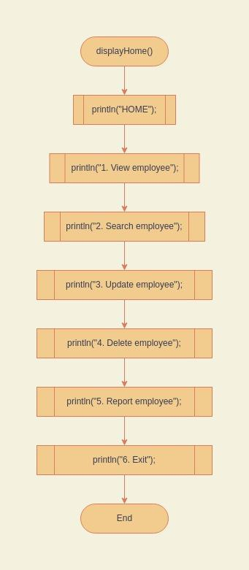

* **Function viewEmployees**

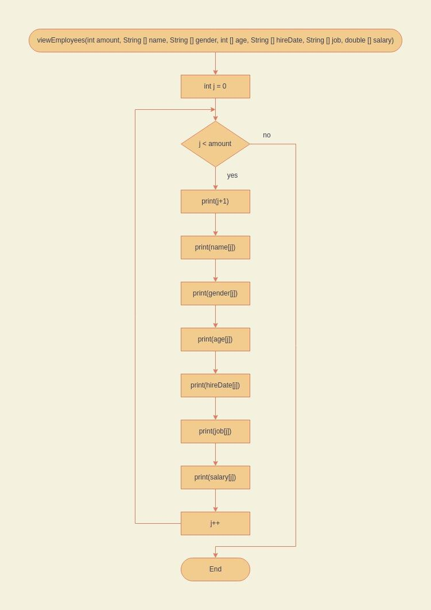

* **Function createEmployee**

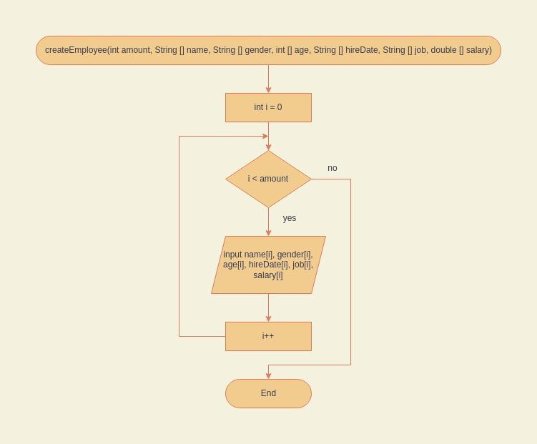

* **Function updateEmployee**

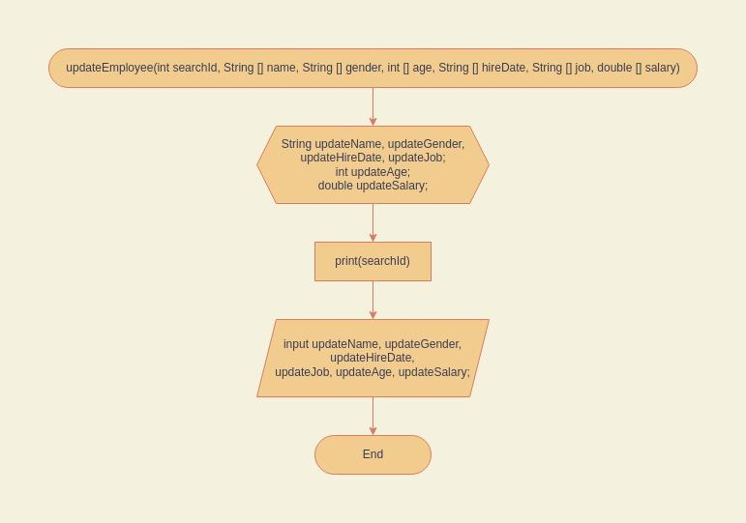

* **Function deleteName**

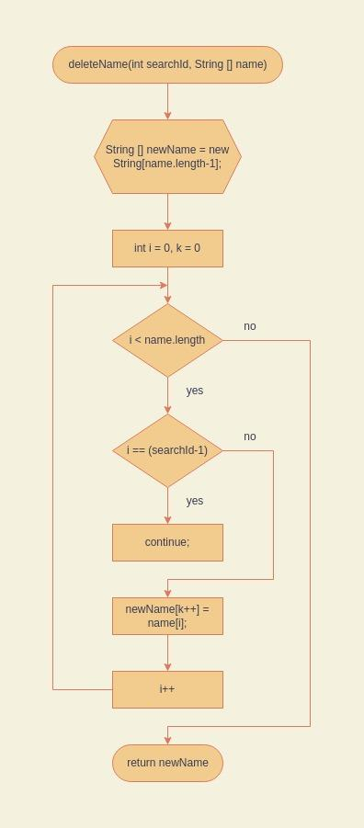

* **Function deleteGender**

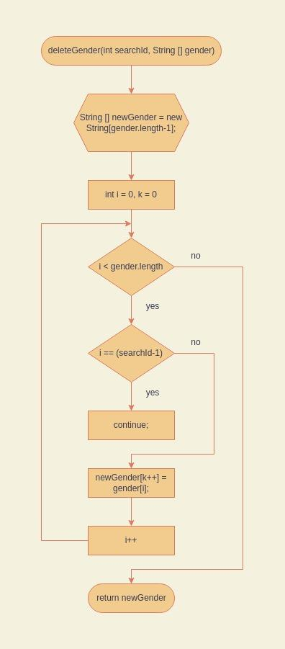

* **Function deleteAge**

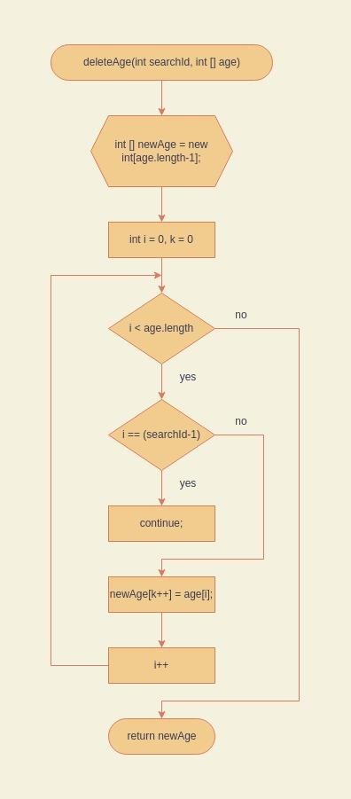

* **Function deleteHireDate**

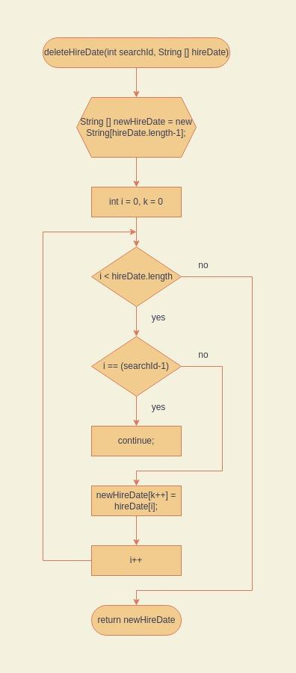

**Function deleteJob**

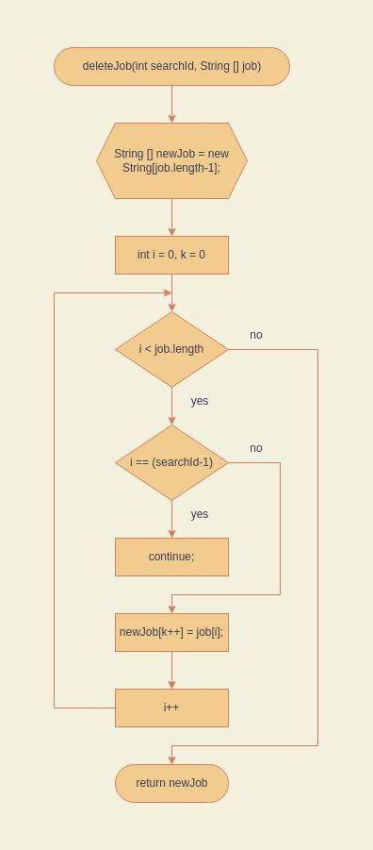

**Function deleteSalary**

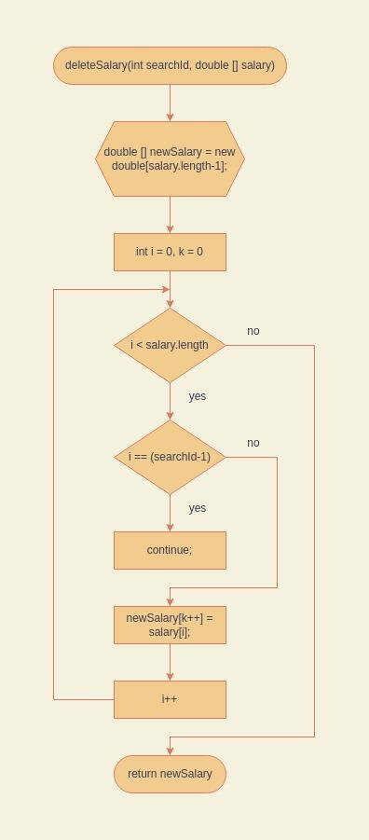

**Function searchEmployee**

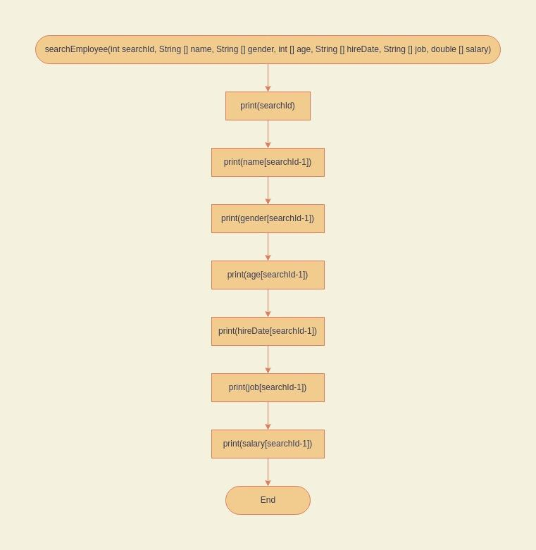

**Function reportEmployee**

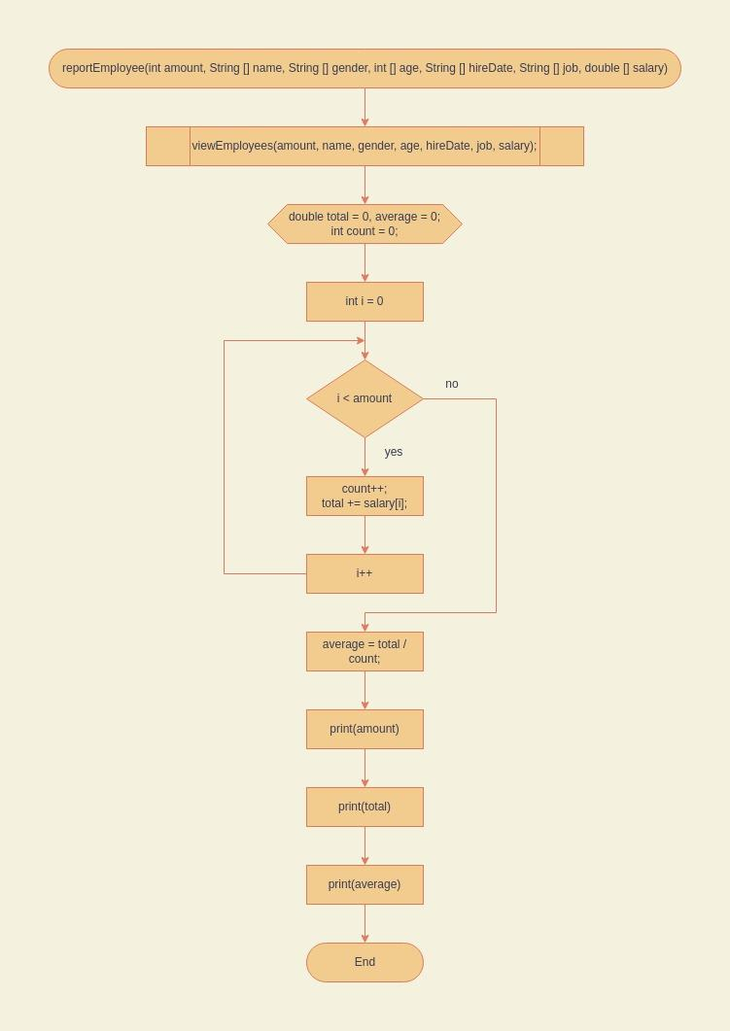

**Function print**

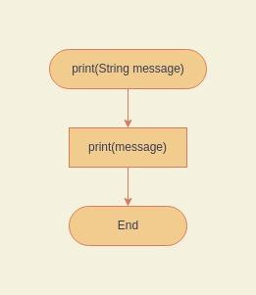

**Function println**

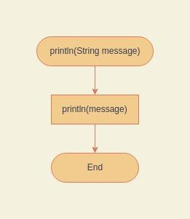

**Function main**

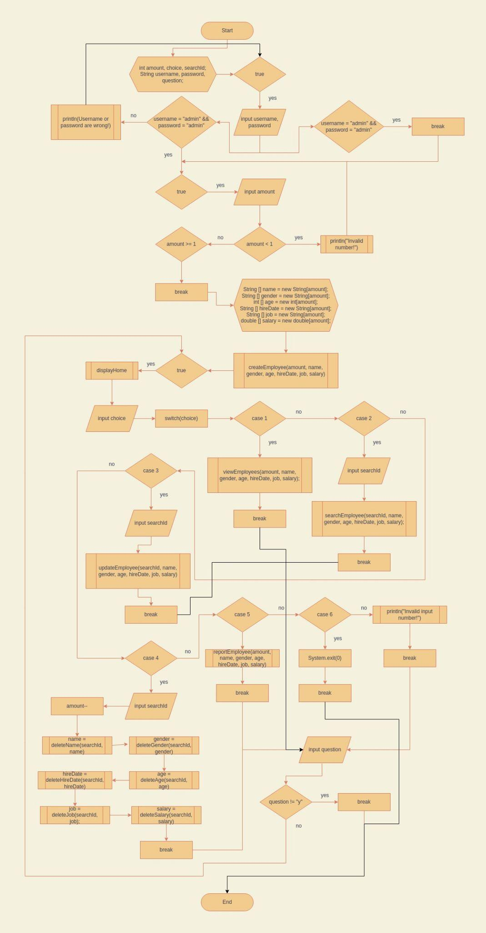

**1.2 Steps to Run the Program**

* First, log in by inputting a username with admin and a password with admin too.

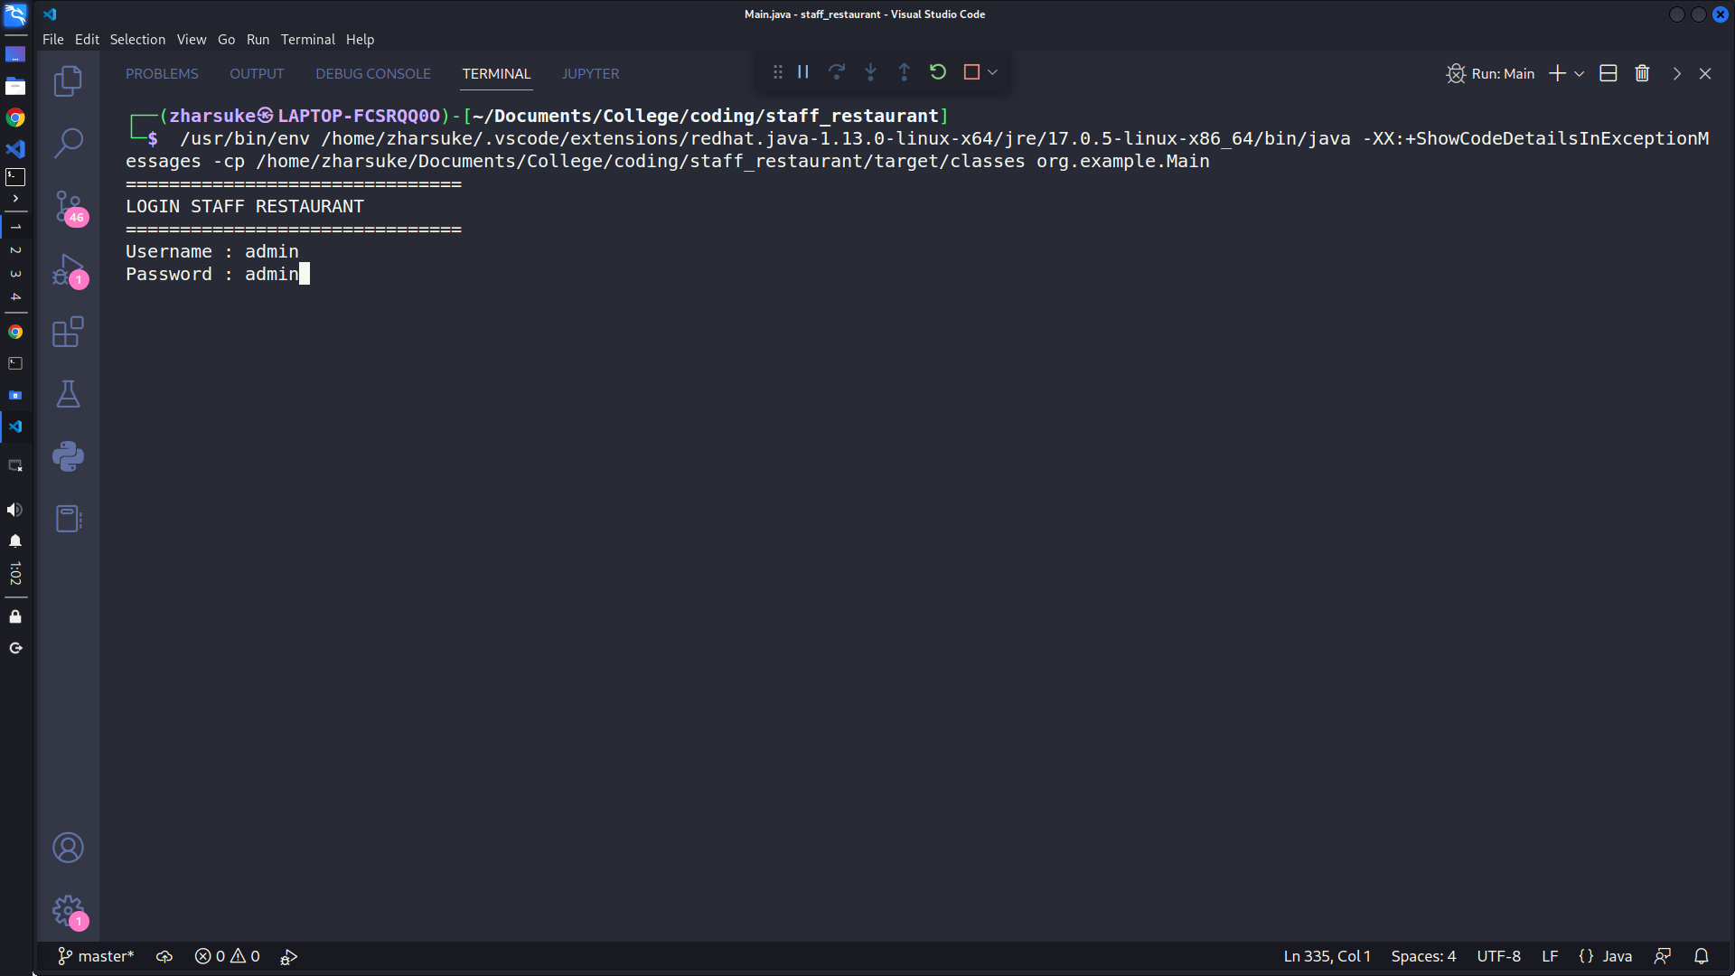

* If the user inputs the wrong username and password, there will be a username or password error message and the user must input again.

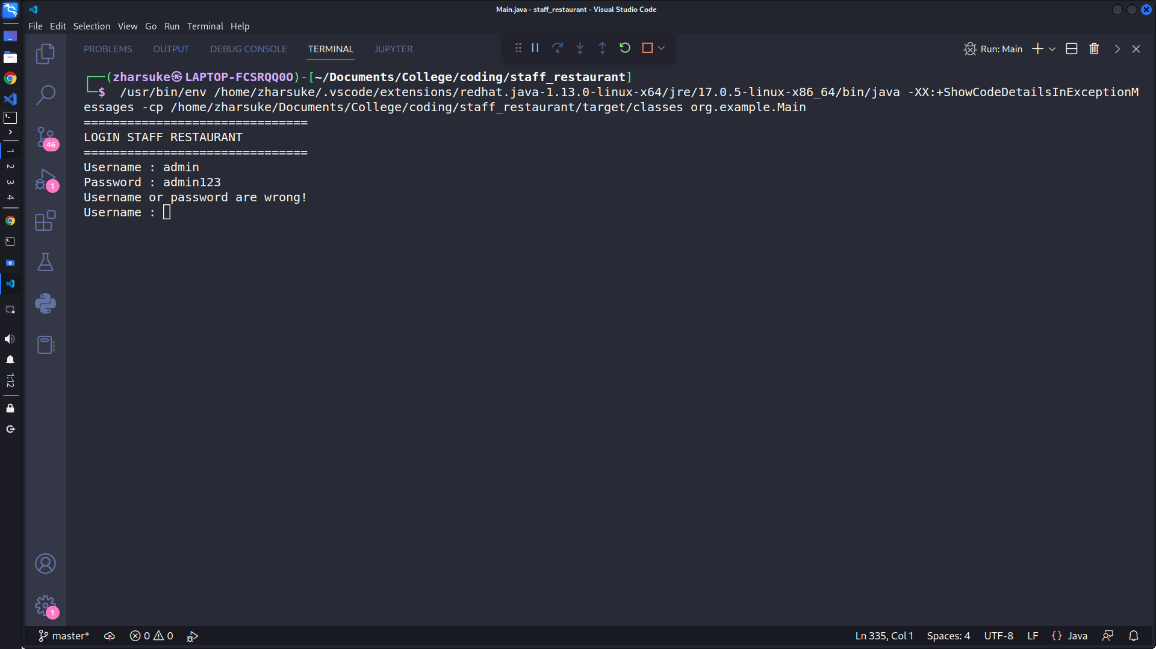

* After login, the user must input the amount of employees that the user wants.

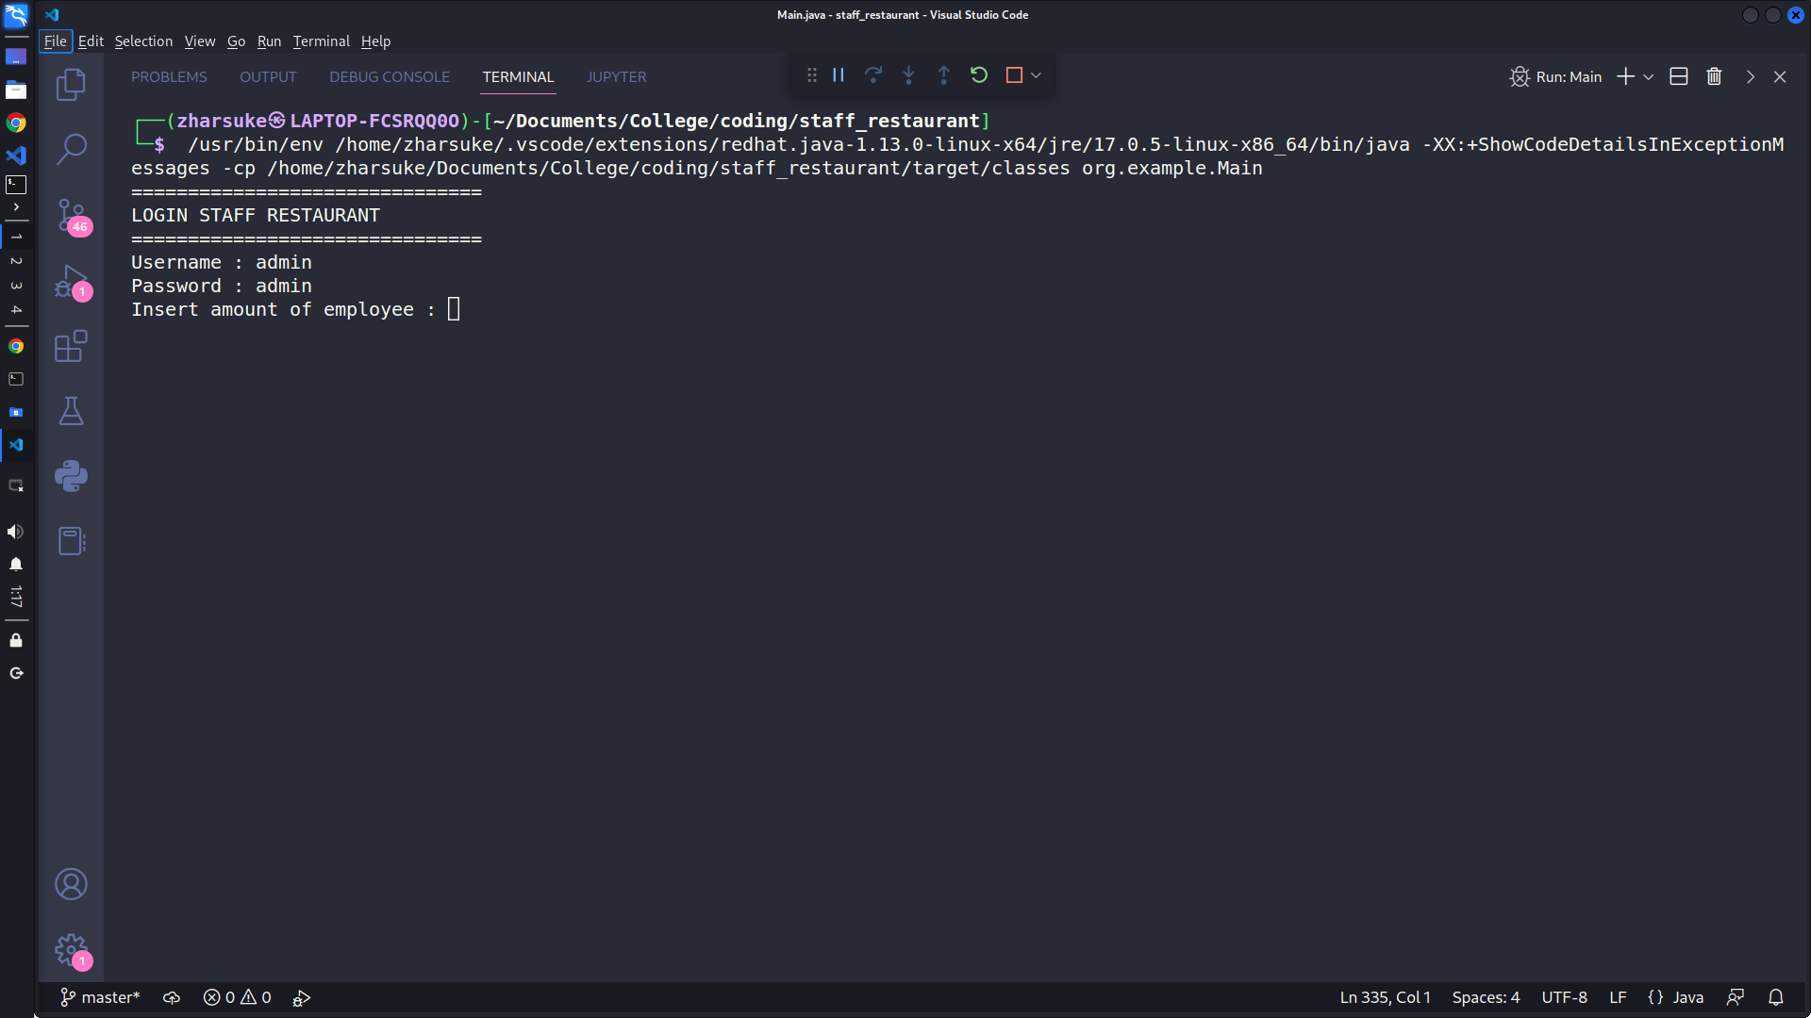

* If a user inputs a number less than one, then an error message will appear and the user must input again.

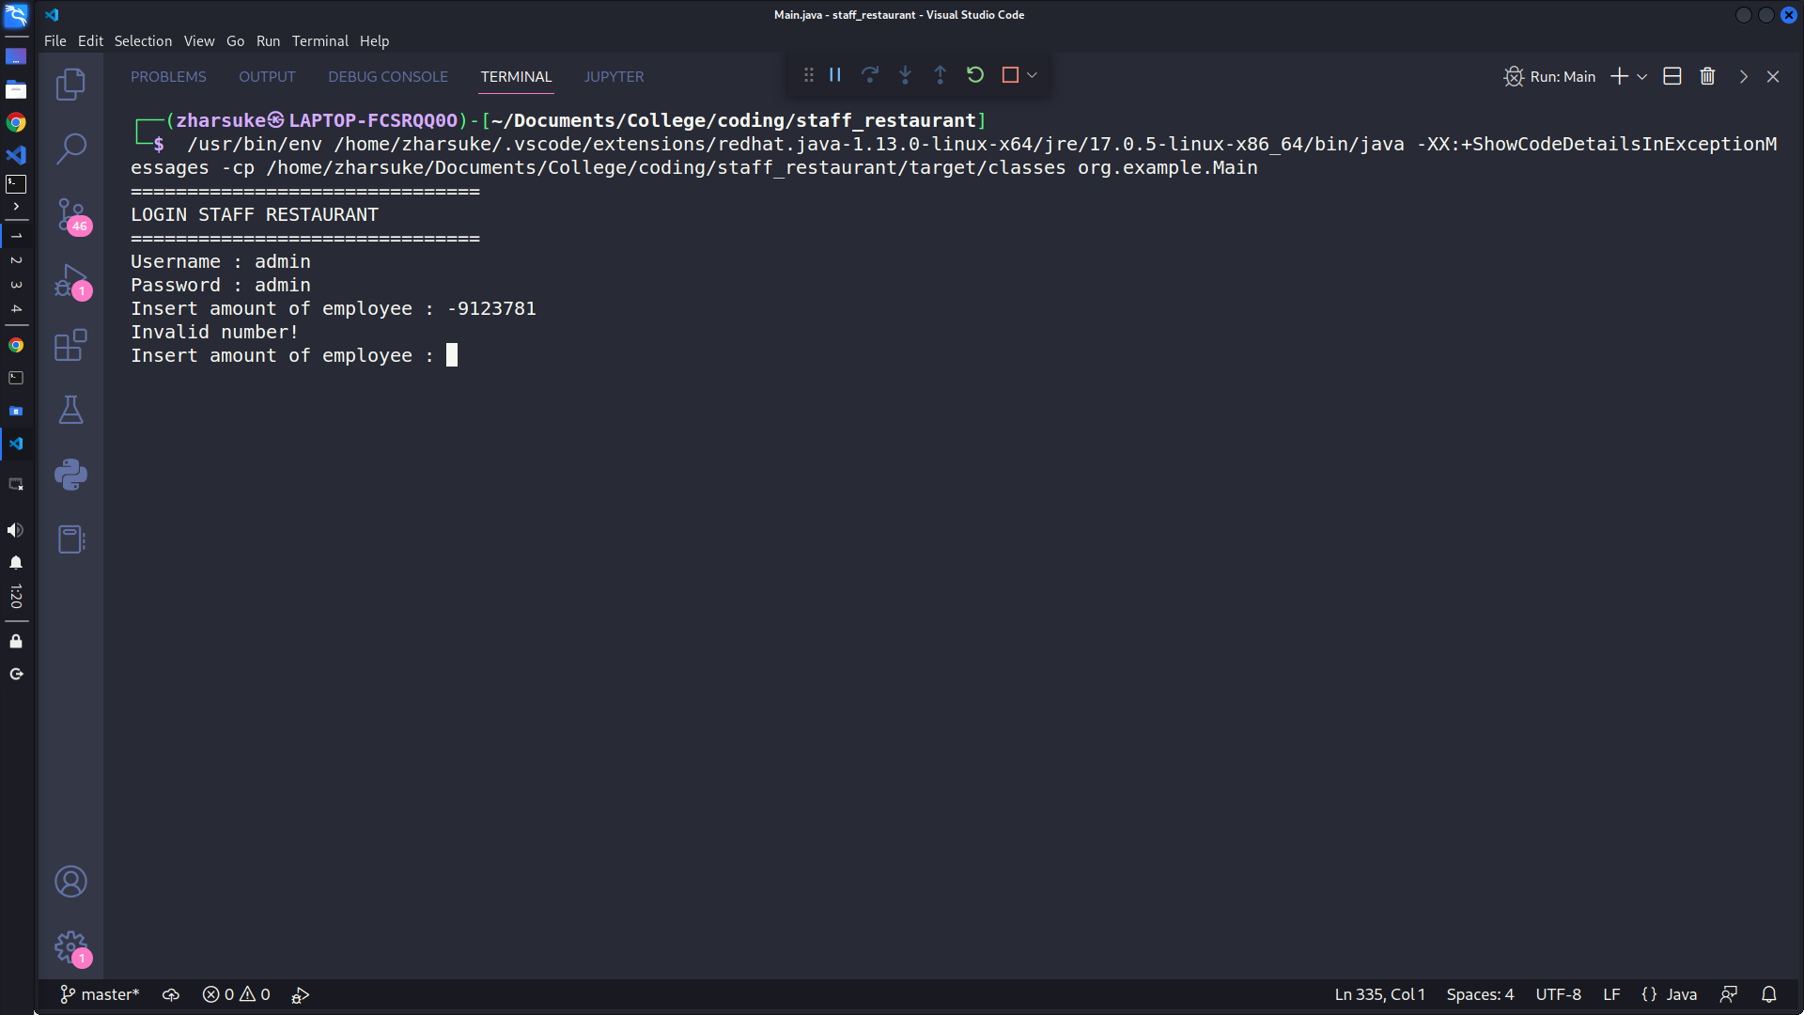

* After the user input the amount of employees, the user must input the data of employees.

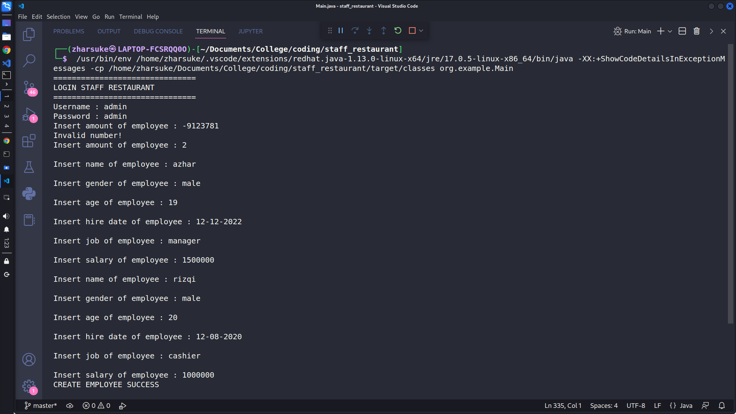

* The home menu appears. There are 6 menus: view employee, search employee, update employee and delete employee dan exit.

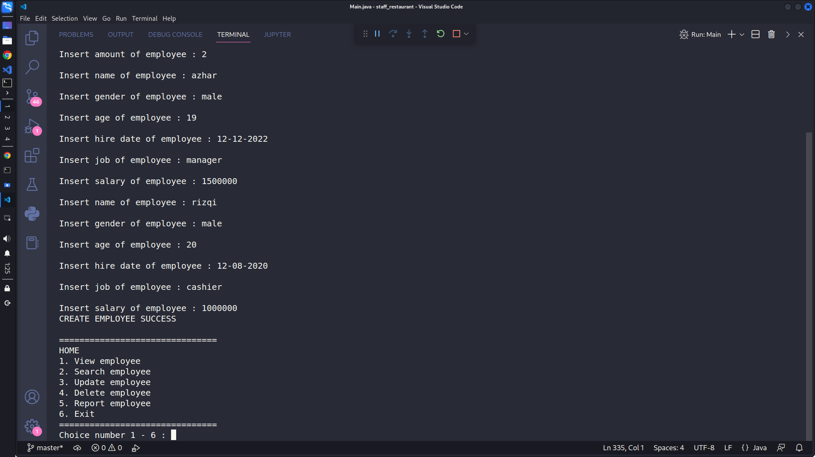

* If the user input numbers other than 1 - 6, then an error message will appear. And there is question input again or no.

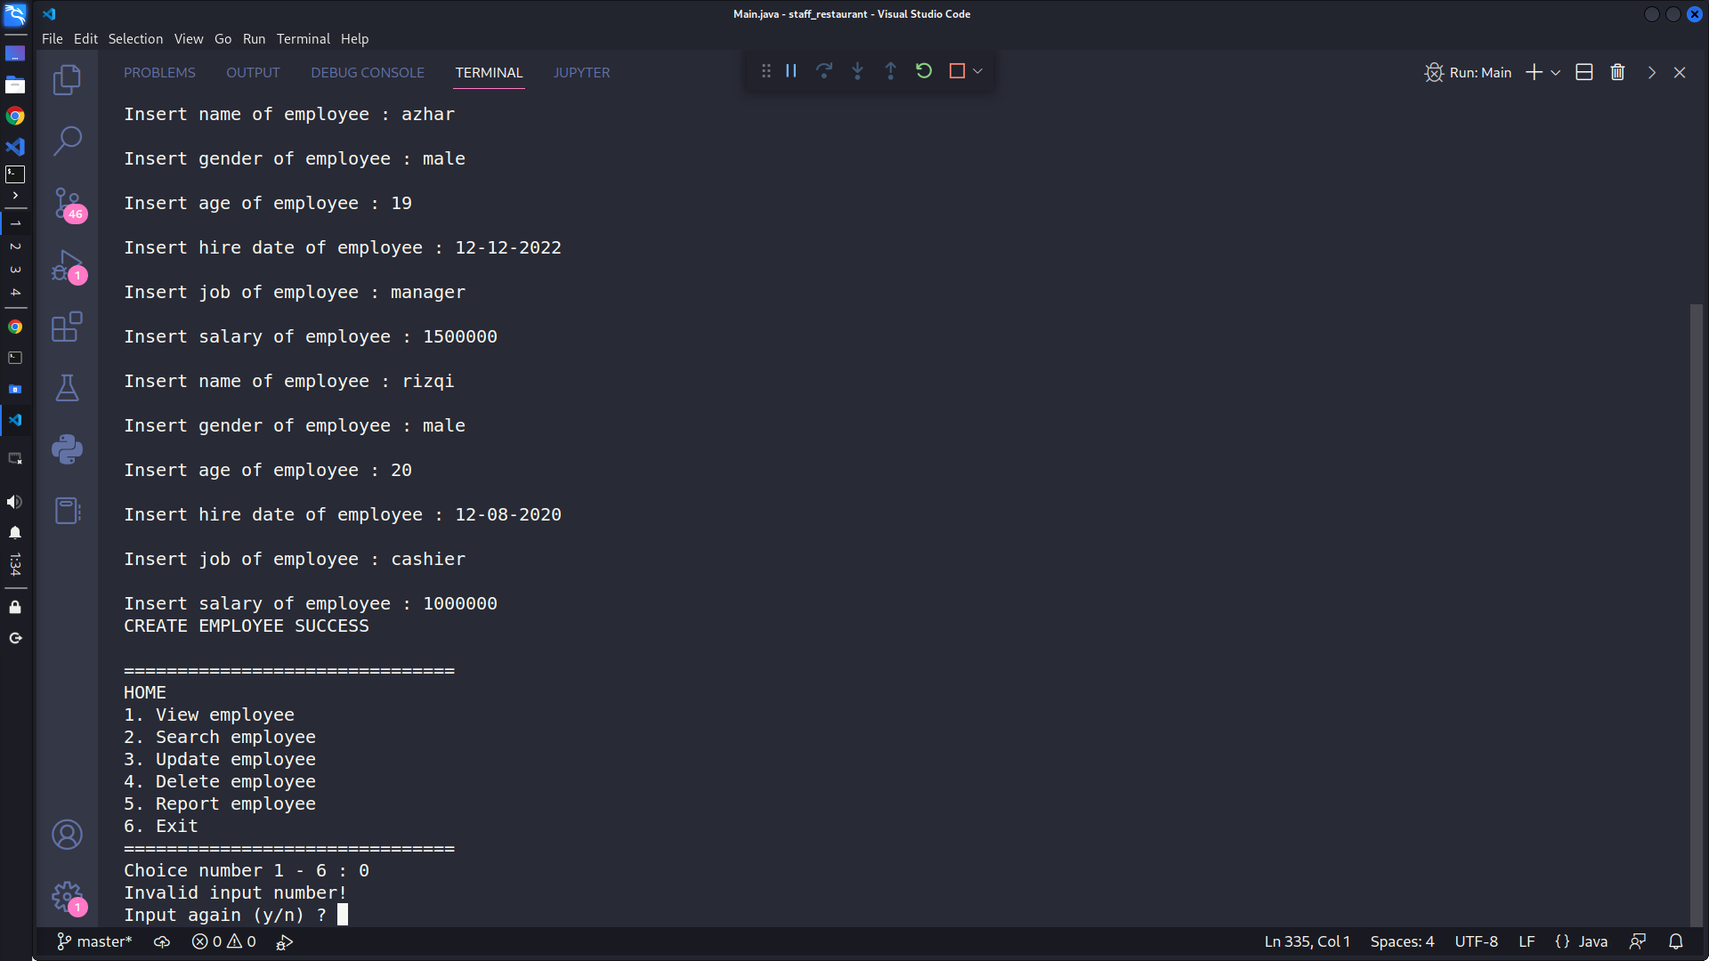

* If the user input 1, then the program will display data of all employees that the user created before.

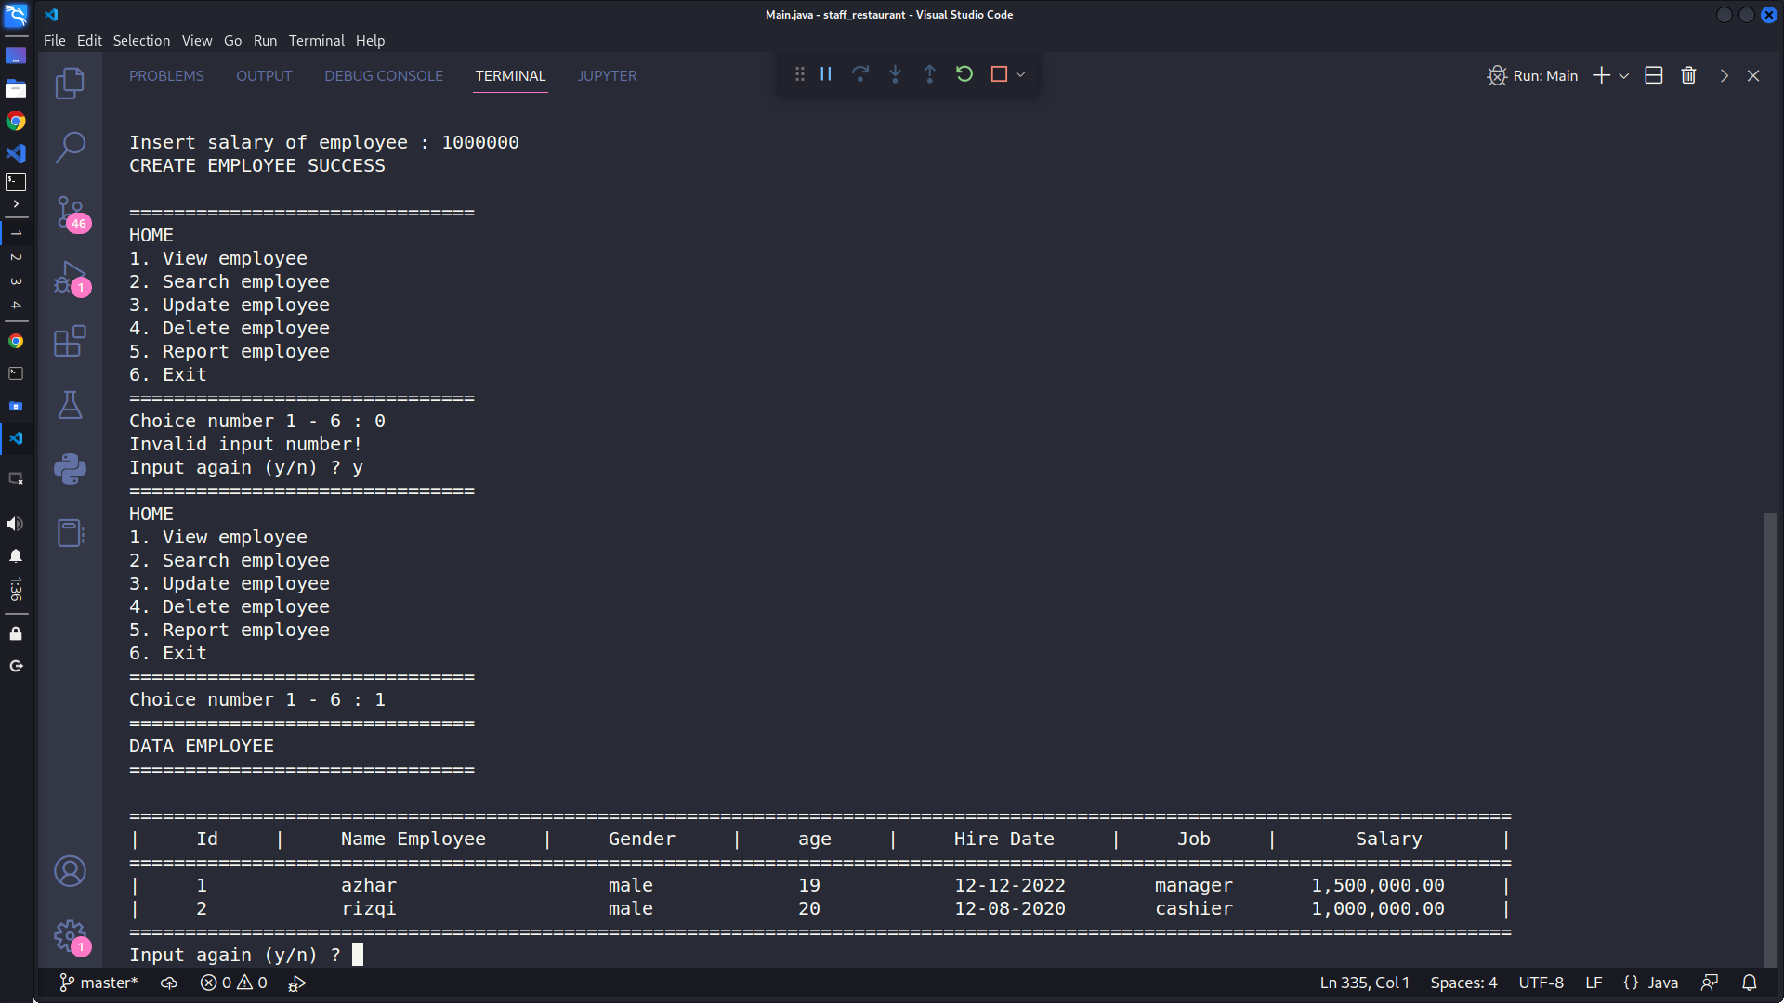

* After that, if the user input number 2, then the user must input the id of the employee as identification.

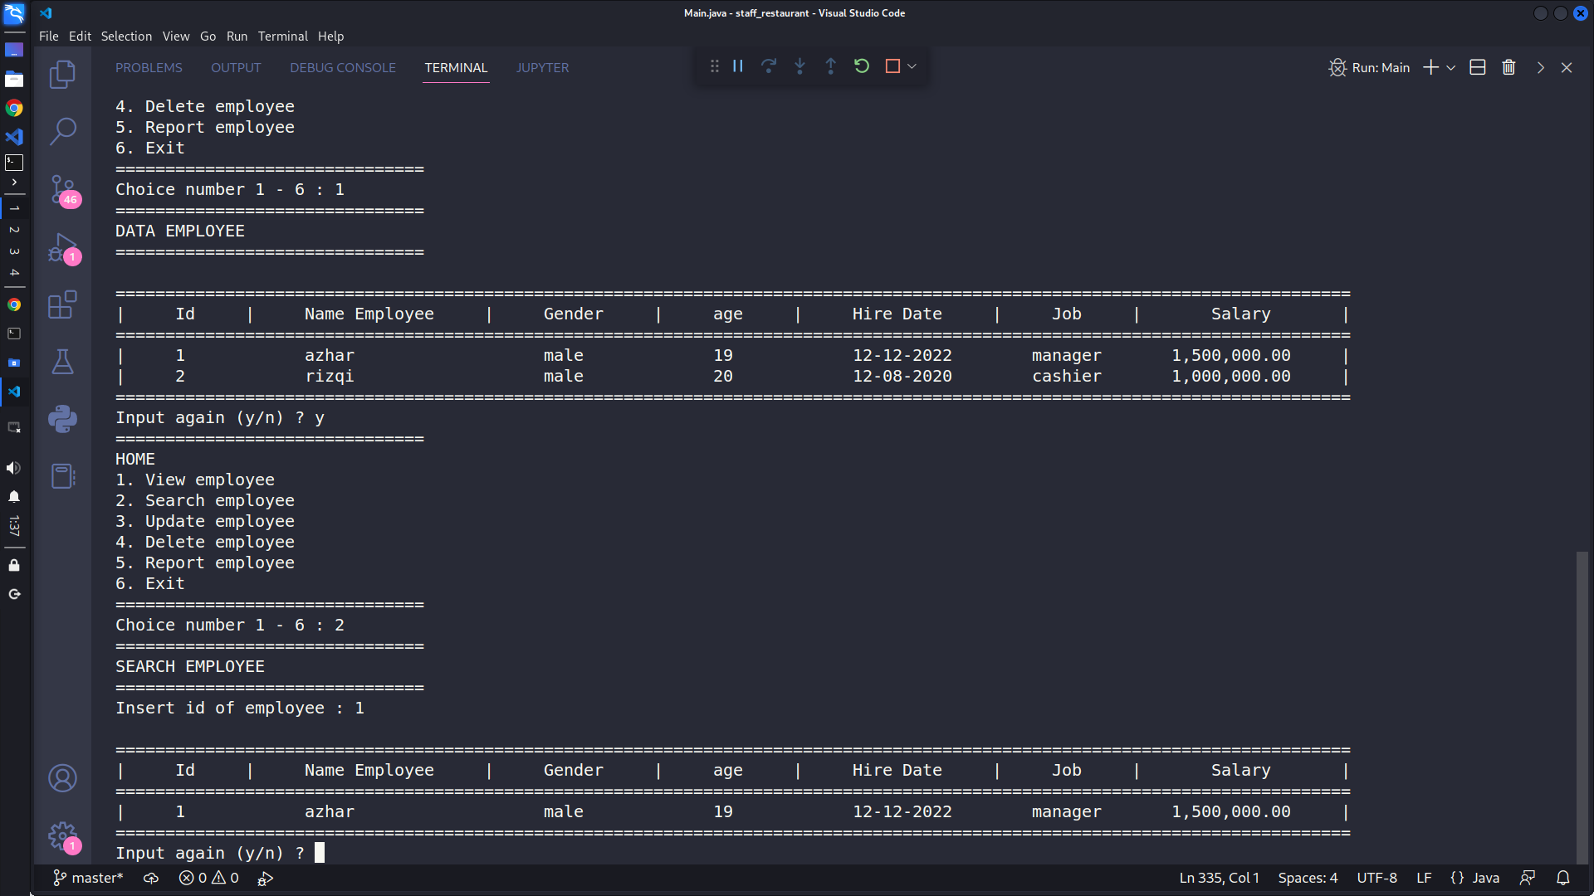

* At the update menu, the user can update the data of employees by inputting employee ID as identification.

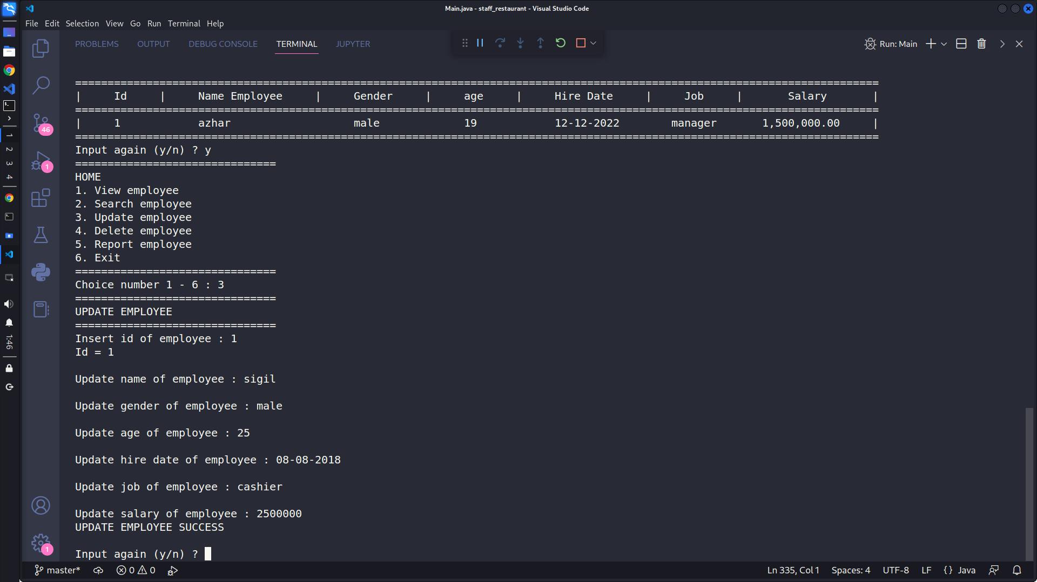

* After edit.

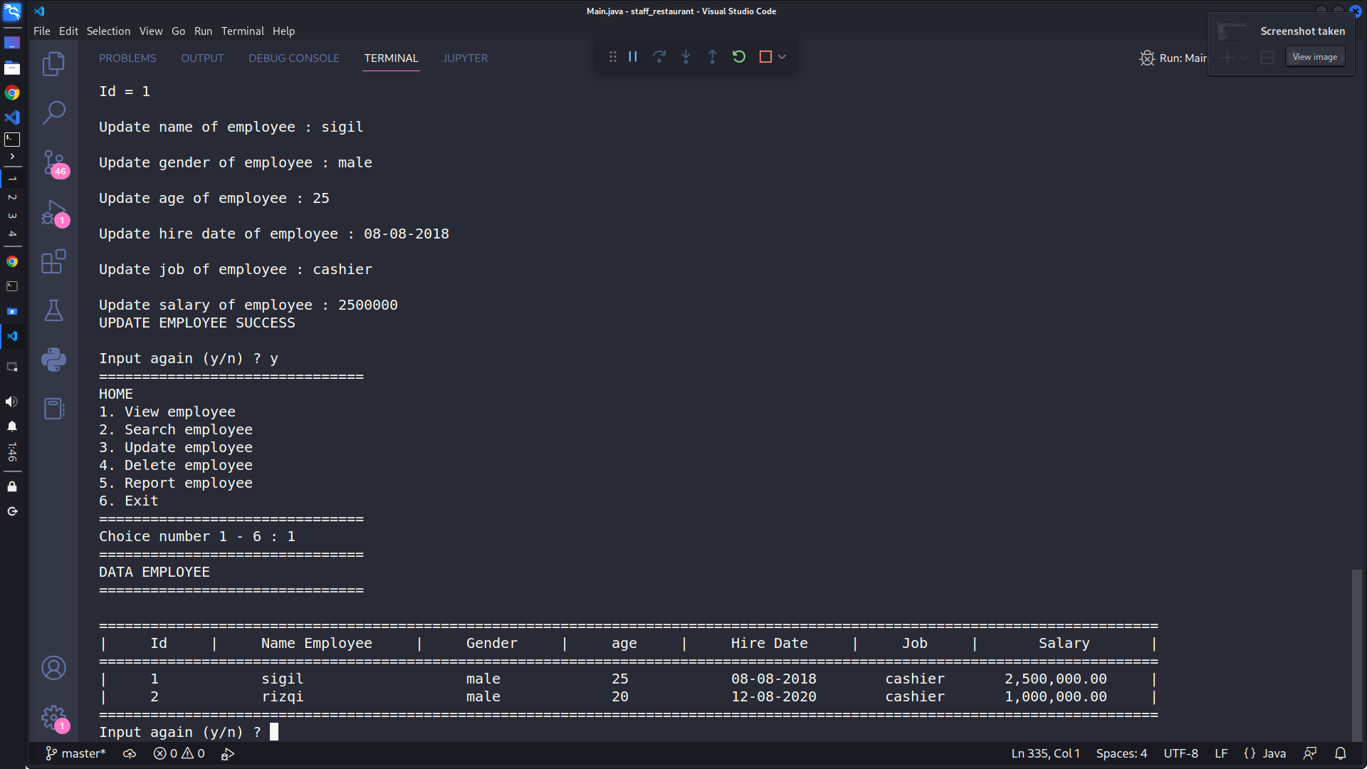

* At menu delete, the user can delete the data of an employee by inputting the id employee as identification.

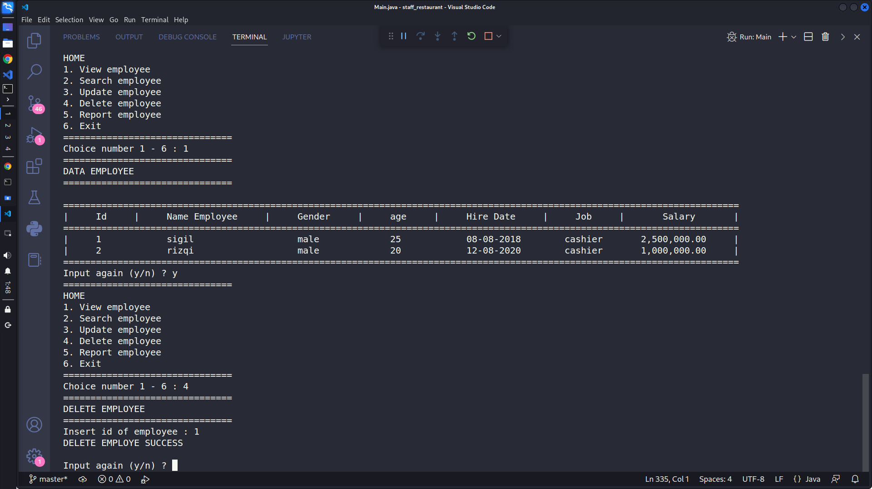

* Data employee after deletion.

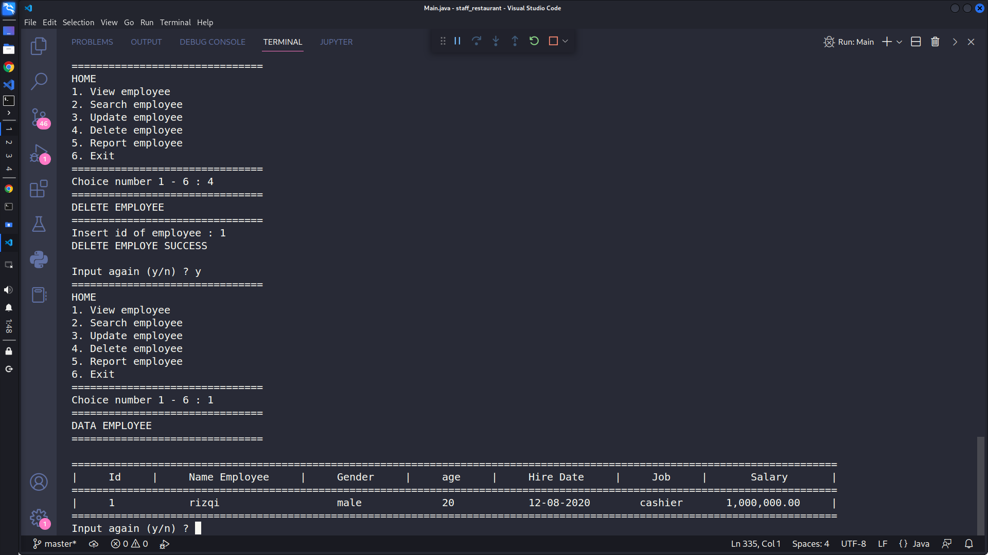

* At the report menu, the user can see data on employees, the total amount of employees, the total salary of employees, and the average salary of employees.
* After inputting data of the employee again.

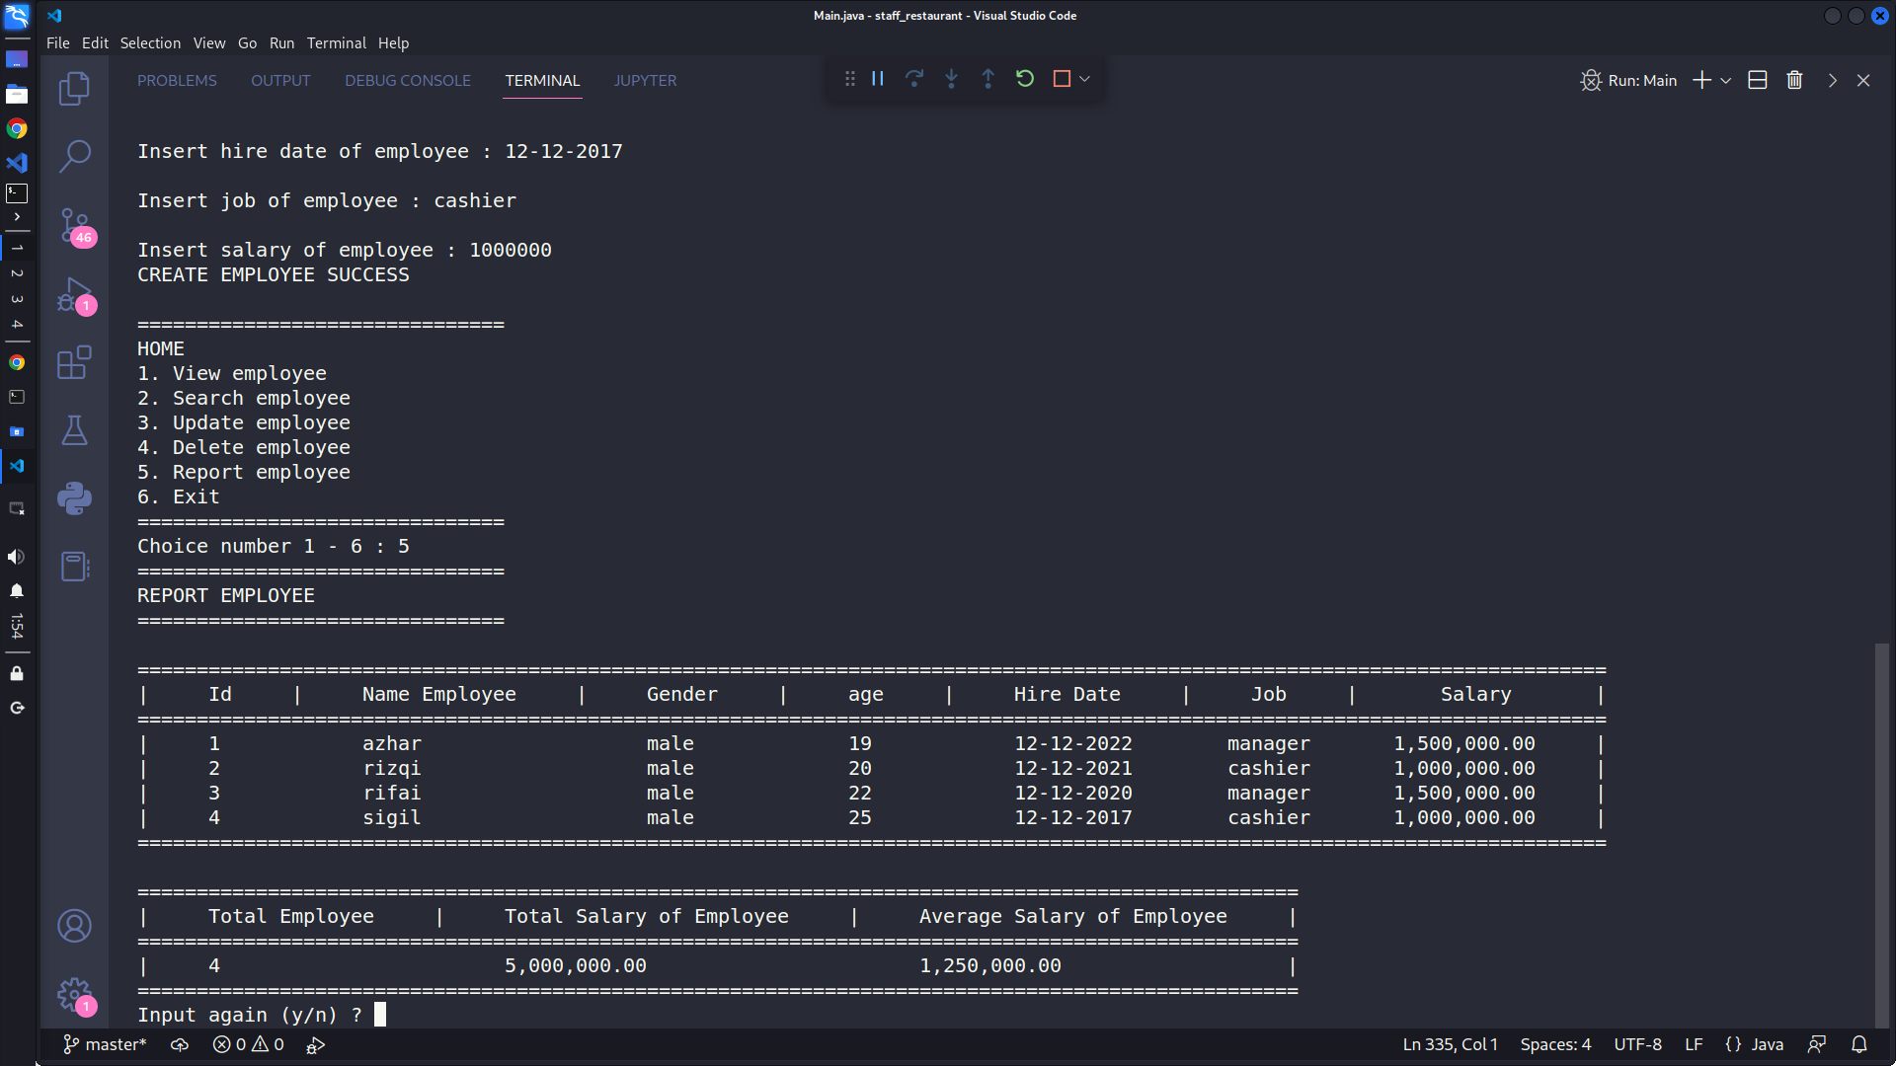

* And the last menu is an exit. If the user input 6, then the program will stop.

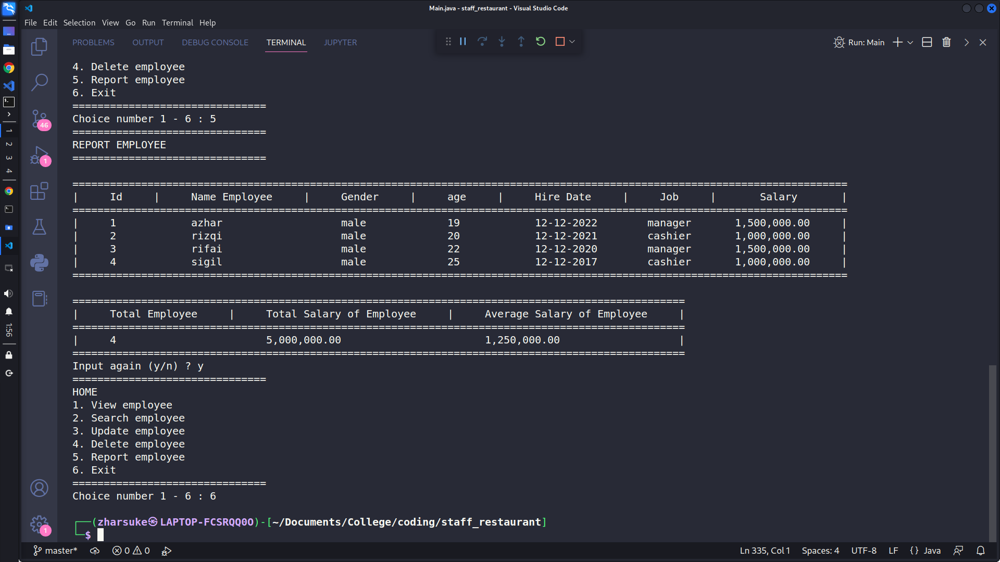

**The following are the steps for running the application**

**1. This application has several features such as creating employee data, viewing employee data, searching employee data, changing employee data, deleting employee data, and viewing employee data reports.**

**2. Before accessing the application, users are required to log in first. After logging in, the user inputs the number of employees they want to add and then fills in the employee data.**

**3. After filling in the employee data, the user can access several menus such as viewing all employee data that has been created by inputting the number 1, then searching for employee data by inputting the number 2, updating employee data by inputting number 3, delete employee data by inputting number 4, view employee reports by inputting number 5, and exit the program by inputting number 6.**

**1.3 Program Code**

* **Function displayHome**

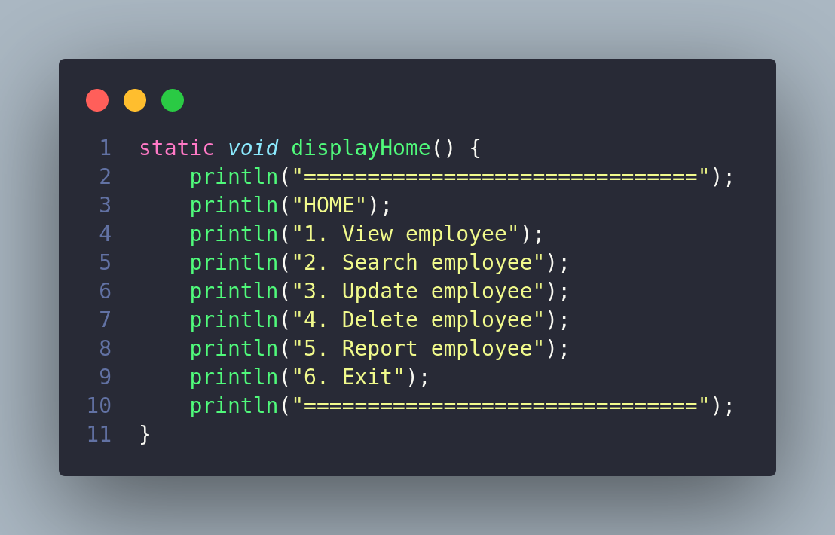

**Function viewEmployee**

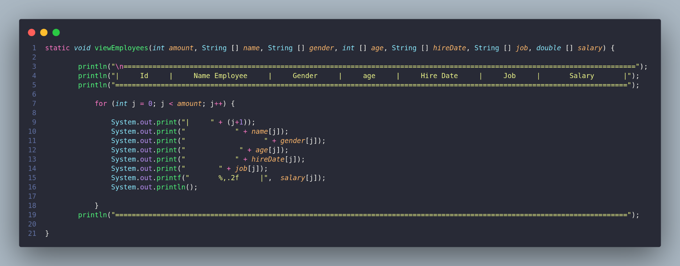

**Function createEmployee**

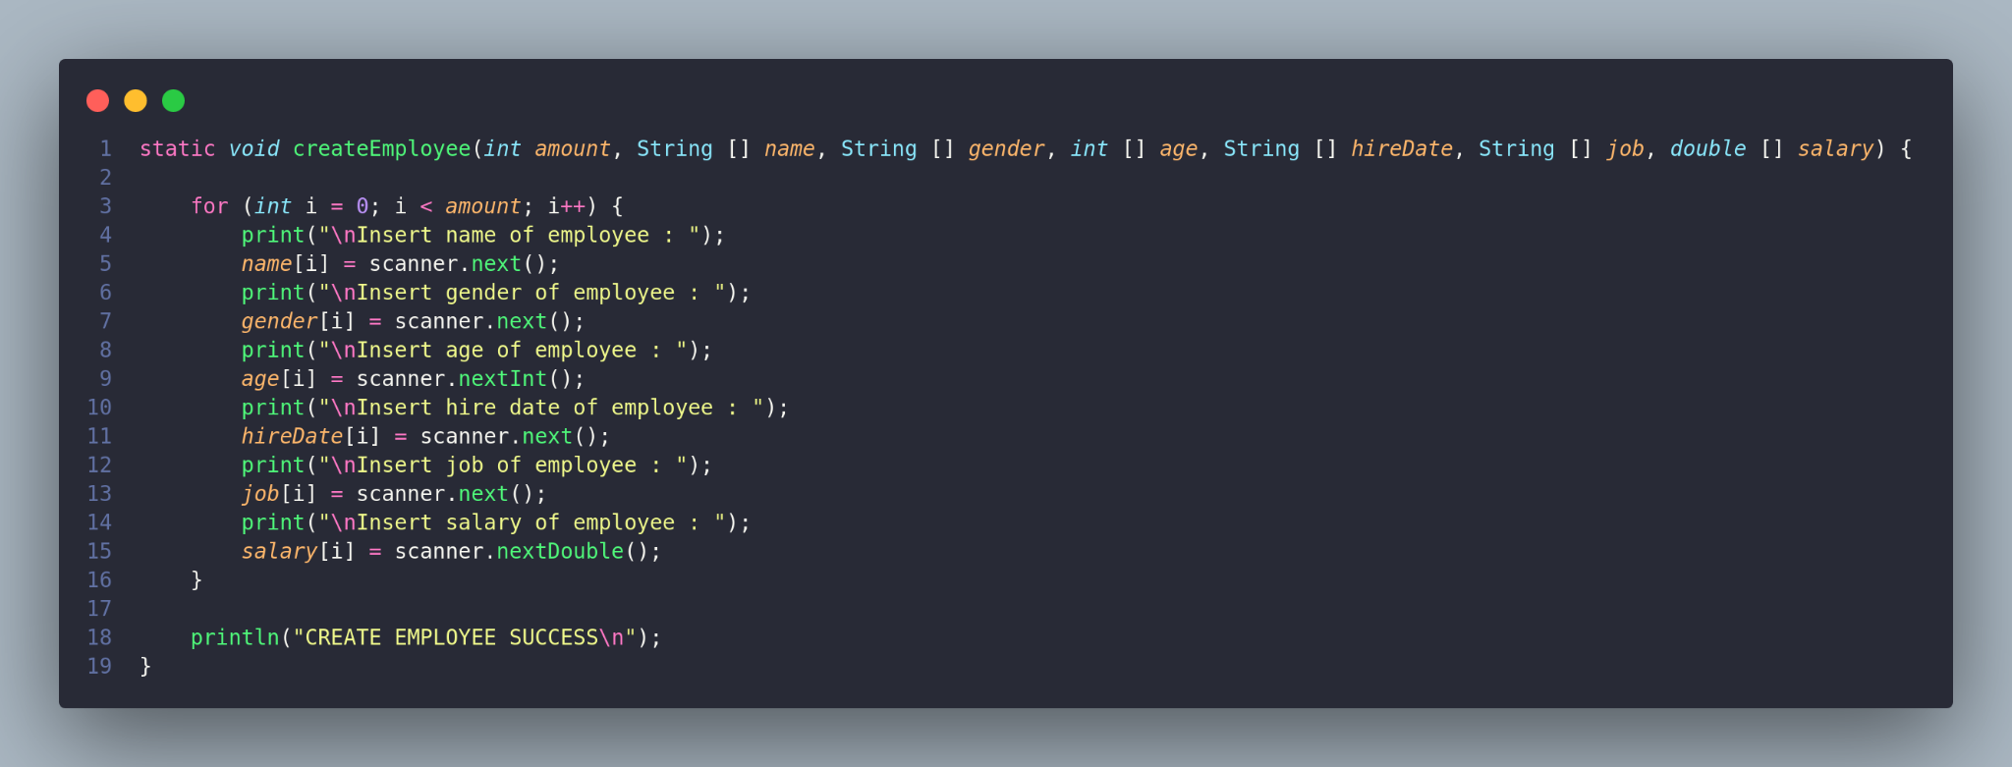

**function updateEmployee**

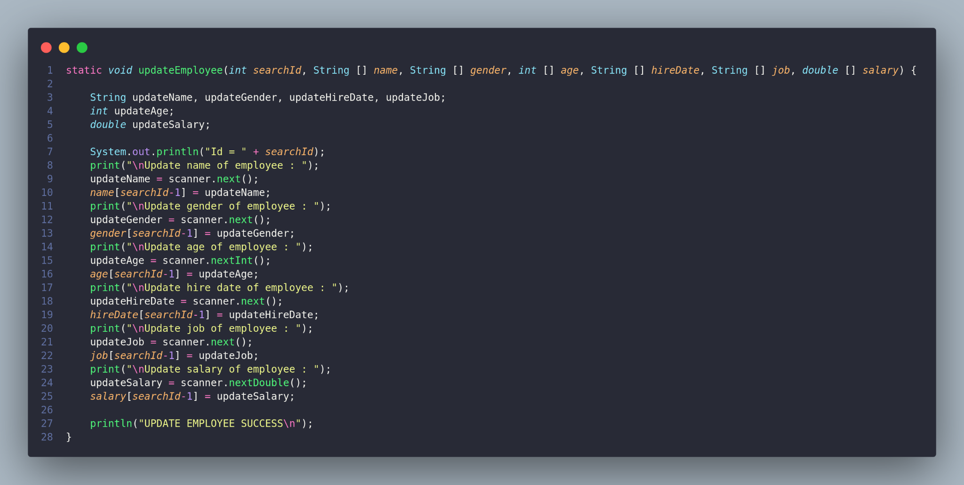

**function deleteName**

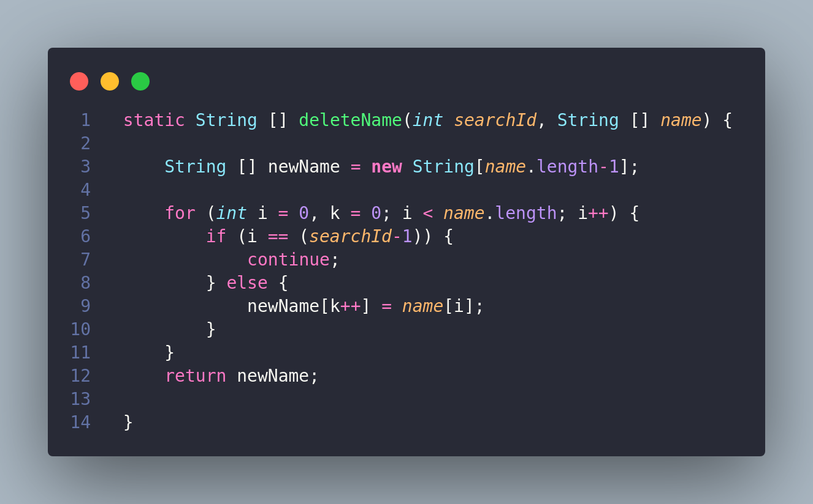

**function deleteGender**

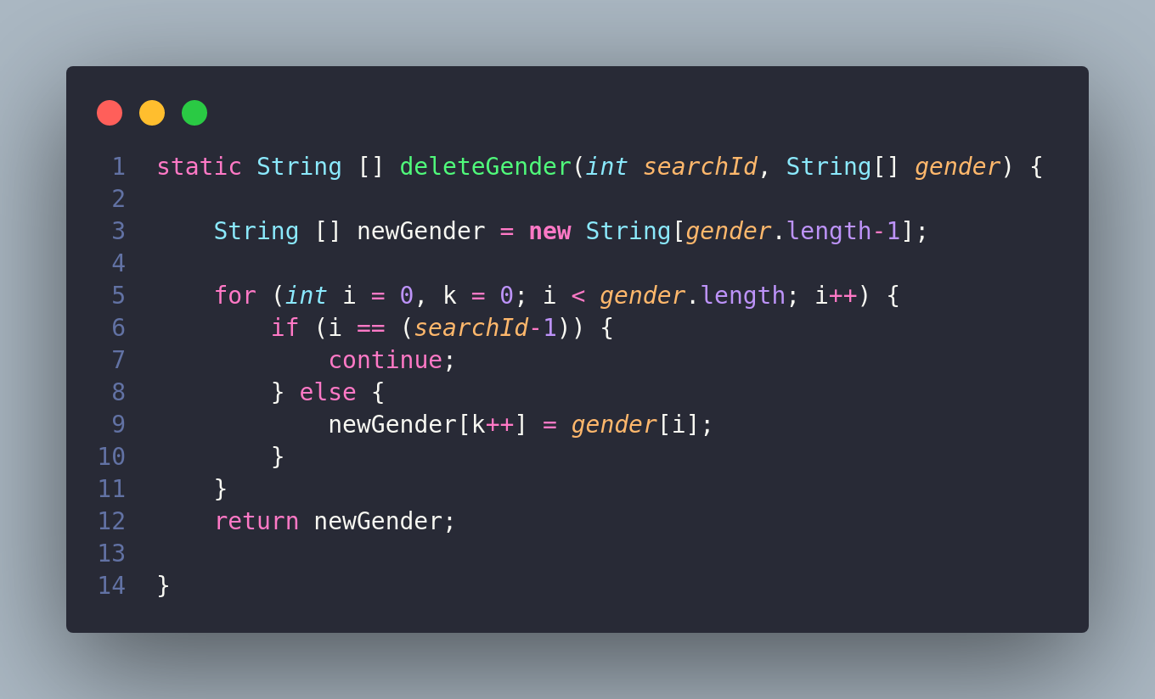

**function deleteAge**

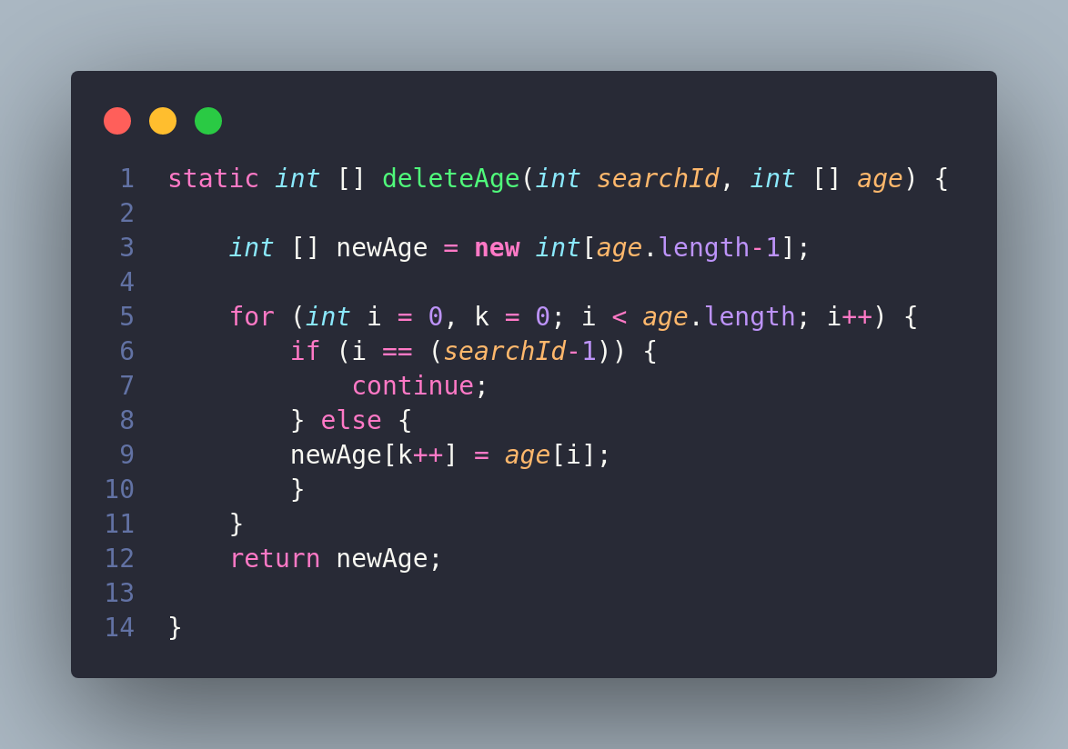

**function deleteHireDate**

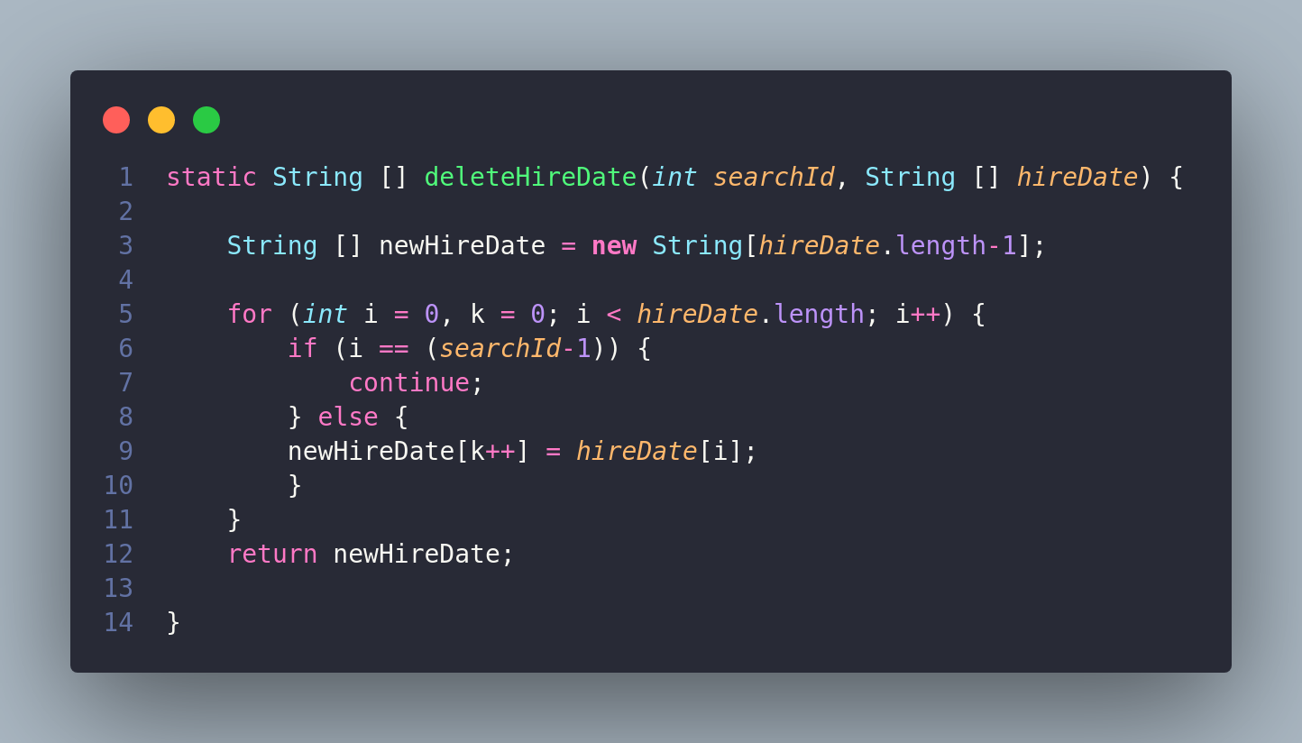

**Function deleteJob**

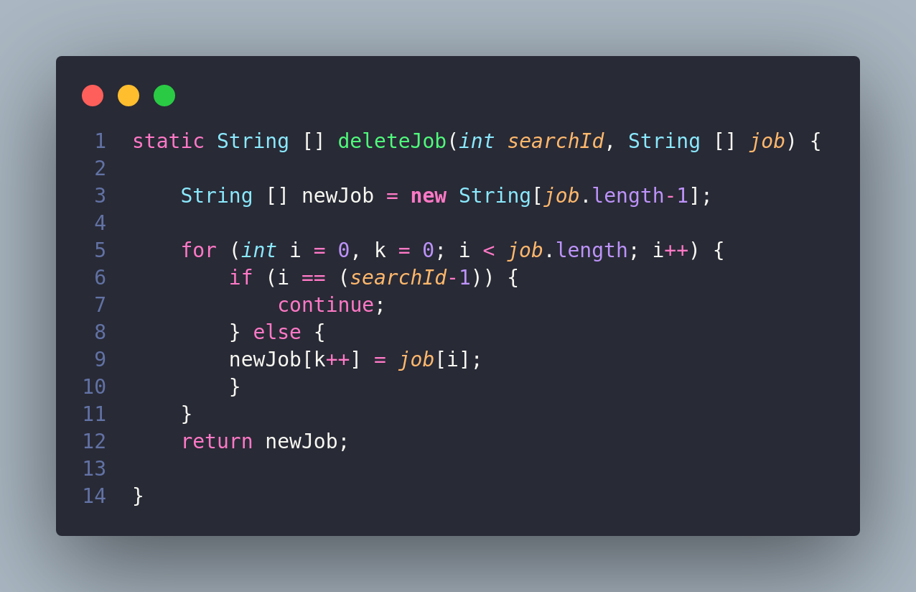

**Function deleteSalary**

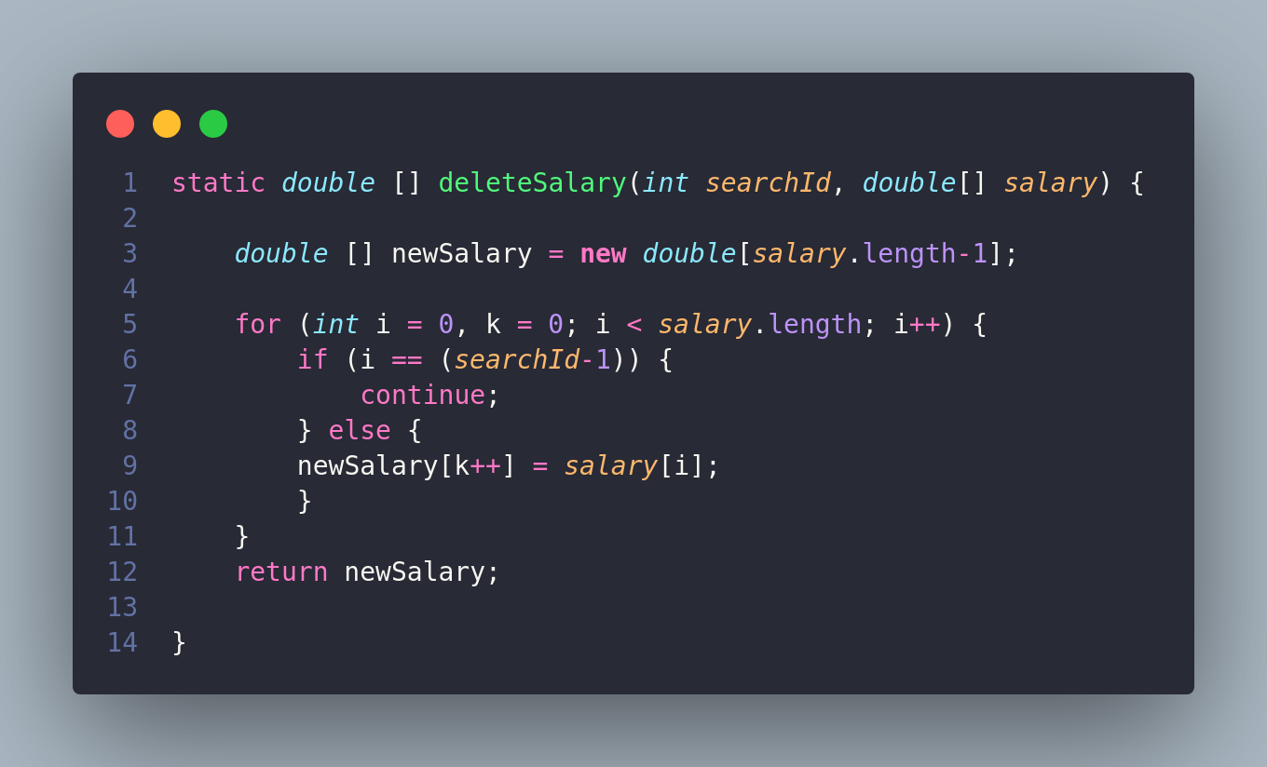

**Function searchEmployee**

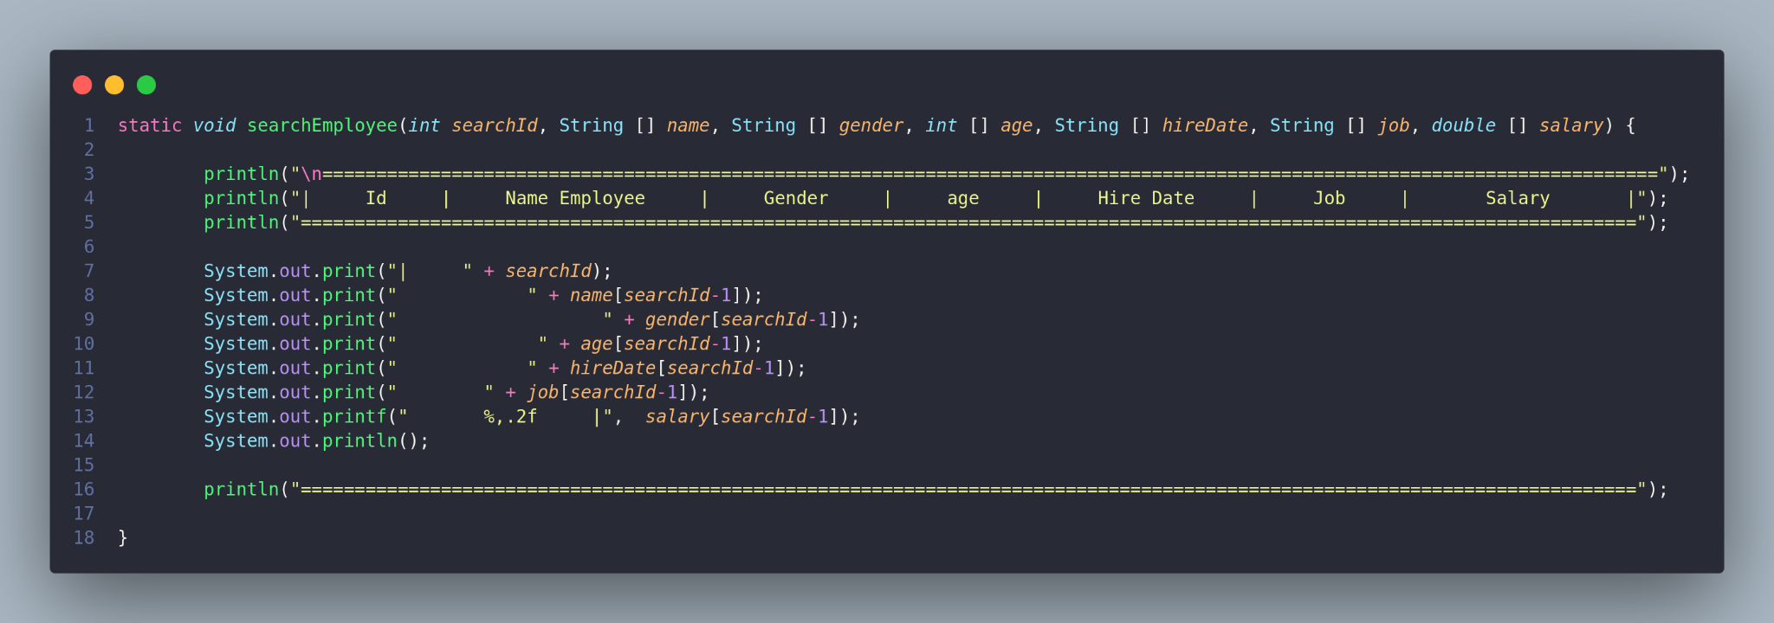

**Function reportEmployee**

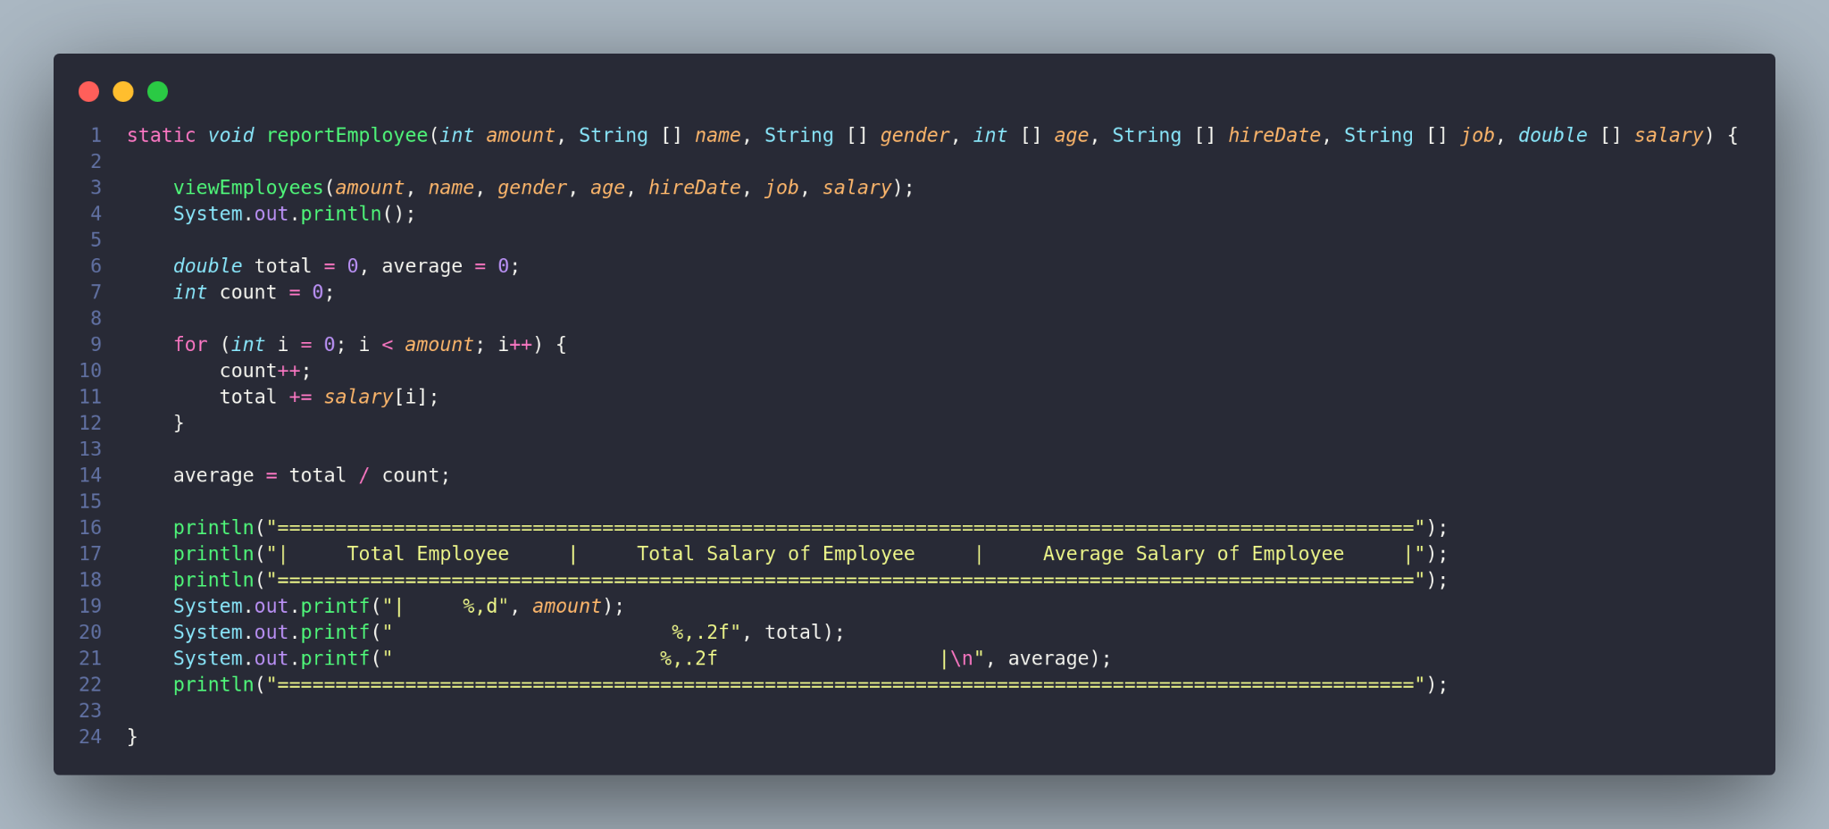

**Function print**

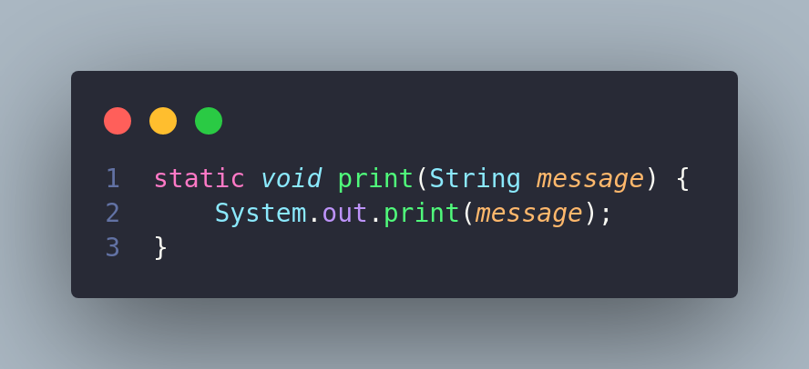

**function println**

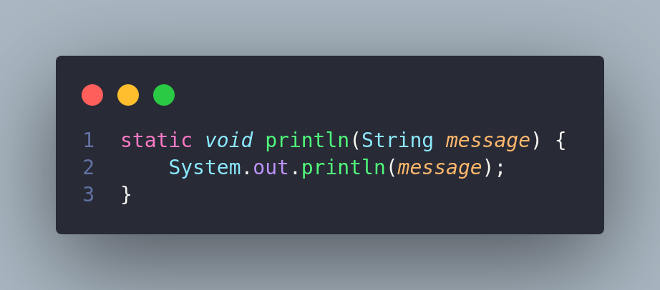

**Function main**

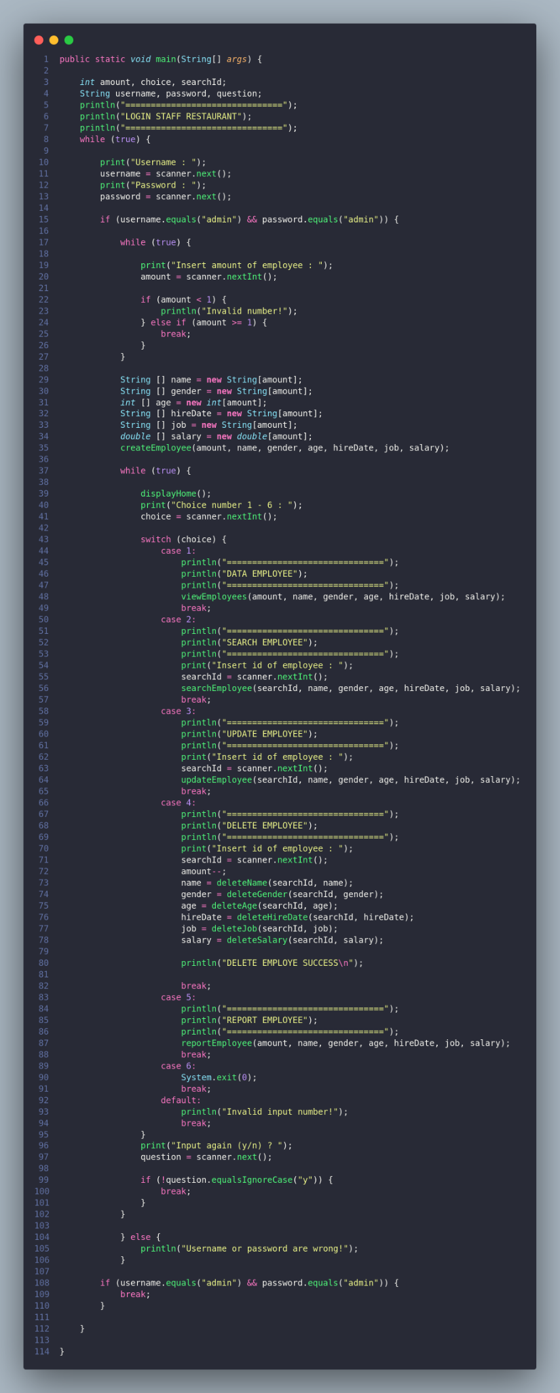

package org.example;

import java.util.Scanner;

public class Main {

static Scanner scanner = new Scanner(System.in);

static void displayHome() {

println("===============================");

println("HOME");

println("1. View employee");

println("2. Search employee");

println("3. Update employee");

println("4. Delete employee");

println("5. Report employee");

println("6. Exit");

println("===============================");

}

static void viewEmployees(int amount, String [] name, String [] gender, int [] age, String [] hireDate, String [] job, double [] salary) { println("\n============================================================================================================================");

println("| Id | Name Employee | Gender | age | Hire Date | Job | Salary |"); println("============================================================================================================================");

for (int j = 0; j < amount; j++) {

System.out.print("| " + (j+1));

System.out.print(" " + name[j]);

System.out.print(" " + gender[j]);

System.out.print(" " + age[j]);

System.out.print(" " + hireDate[j]);

System.out.print(" " + job[j]);

System.out.printf(" %,.2f |", salary[j]);

System.out.println();

}

println("============================================================================================================================");

}

static void createEmployee(int amount, String [] name, String [] gender, int [] age, String [] hireDate, String [] job, double [] salary) {

for (int i = 0; i < amount; i++) {

print("\nInsert name of employee : ");

name[i] = scanner.next();

print("\nInsert gender of employee : ");

gender[i] = scanner.next();

print("\nInsert age of employee : ");

age[i] = scanner.nextInt();

print("\nInsert hire date of employee : ");

hireDate[i] = scanner.next();

print("\nInsert job of employee : ");

job[i] = scanner.next();

print("\nInsert salary of employee : ");

salary[i] = scanner.nextDouble();

}

println("CREATE EMPLOYEE SUCCESS\n");

}

static void updateEmployee(int searchId, String [] name, String [] gender, int [] age, String [] hireDate, String [] job, double [] salary) {

String updateName, updateGender, updateHireDate, updateJob;

int updateAge;

double updateSalary;

System.out.println("Id = " + searchId);

print("\nUpdate name of employee : ");

updateName = scanner.next();

name[searchId-1] = updateName;

print("\nUpdate gender of employee : ");

updateGender = scanner.next();

gender[searchId-1] = updateGender;

print("\nUpdate age of employee : ");

updateAge = scanner.nextInt();

age[searchId-1] = updateAge;

print("\nUpdate hire date of employee : ");

updateHireDate = scanner.next();

hireDate[searchId-1] = updateHireDate;

print("\nUpdate job of employee : ");

updateJob = scanner.next();

job[searchId-1] = updateJob;

print("\nUpdate salary of employee : ");

updateSalary = scanner.nextDouble();

salary[searchId-1] = updateSalary;

println("UPDATE EMPLOYEE SUCCESS\n");

}

static String [] deleteName(int searchId, String [] name) {

String [] newName = new String[name.length-1];

for (int i = 0, k = 0; i < name.length; i++) {

if (i == (searchId-1)) {

continue;

} else {

newName[k++] = name[i];

}

}

return newName;

}

static String [] deleteGender(int searchId, String[] gender) {

String [] newGender = new String[gender.length-1];

for (int i = 0, k = 0; i < gender.length; i++) {

if (i == (searchId-1)) {

continue;

} else {

newGender[k++] = gender[i];

}

}

return newGender;

}

static int [] deleteAge(int searchId, int [] age) {

int [] newAge = new int[age.length-1];

for (int i = 0, k = 0; i < age.length; i++) {

if (i == (searchId-1)) {

continue;

} else {

newAge[k++] = age[i];

}

}

return newAge;

}

static String [] deleteHireDate(int searchId, String [] hireDate) {

String [] newHireDate = new String[hireDate.length-1];

for (int i = 0, k = 0; i < hireDate.length; i++) {

if (i == (searchId-1)) {

continue;

} else {

newHireDate[k++] = hireDate[i];

}

}

return newHireDate;

}

static String [] deleteJob(int searchId, String [] job) {

String [] newJob = new String[job.length-1];

for (int i = 0, k = 0; i < job.length; i++) {

if (i == (searchId-1)) {

continue;

} else {

newJob[k++] = job[i];

}

}

return newJob;

}

static double [] deleteSalary(int searchId, double[] salary) {

double [] newSalary = new double[salary.length-1];

for (int i = 0, k = 0; i < salary.length; i++) {

if (i == (searchId-1)) {

continue;

} else {

newSalary[k++] = salary[i];

}

}

return newSalary;

}

static void searchEmployee(int searchId, String [] name, String [] gender, int [] age, String [] hireDate, String [] job, double [] salary) { println("\n============================================================================================================================");

println("| Id | Name Employee | Gender | age | Hire Date | Job | Salary |"); println("============================================================================================================================");

System.out.print("| " + searchId);

System.out.print(" " + name[searchId-1]);

System.out.print(" " + gender[searchId-1]);

System.out.print(" " + age[searchId-1]);

System.out.print(" " + hireDate[searchId-1]);

System.out.print(" " + job[searchId-1]);

System.out.printf(" %,.2f |", salary[searchId-1]);

System.out.println(); println("============================================================================================================================");

}

static void reportEmployee(int amount, String [] name, String [] gender, int [] age, String [] hireDate, String [] job, double [] salary) {

viewEmployees(amount, name, gender, age, hireDate, job, salary);

System.out.println();

double total = 0, average = 0;

int count = 0;

for (int i = 0; i < amount; i++) {

count++;

total += salary[i];

}

average = total / count;

println("==================================================================================================");

println("| Total Employee | Total Salary of Employee | Average Salary of Employee |");

println("==================================================================================================");

System.out.printf("| %,d", amount);

System.out.printf(" %,.2f", total);

System.out.printf(" %,.2f |\n", average); println("==================================================================================================");

}

static void print(String message) {

System.out.print(message);

}

static void println(String message) {

System.out.println(message);

}

public static void main(String[] args) {

int amount, choice, searchId;

String username, password, question;

println("===============================");

println("LOGIN STAFF RESTAURANT");

println("===============================");

while (true) {

print("Username : ");

username = scanner.next();

print("Password : ");

password = scanner.next();

if (username.equals("admin") && password.equals("admin")) {

while (true) {

print("Insert amount of employee : ");

amount = scanner.nextInt();

if (amount < 1) {

println("Invalid number!");

} else if (amount >= 1) {

break;

}

}

String [] name = new String[amount];

String [] gender = new String[amount];

int [] age = new int[amount];

String [] hireDate = new String[amount];

String [] job = new String[amount];

double [] salary = new double[amount];

createEmployee(amount, name, gender, age, hireDate, job, salary);

while (true) {

displayHome();

print("Choice number 1 - 6 : ");

choice = scanner.nextInt();

switch (choice) {

case 1:

println("===============================");

println("DATA EMPLOYEE");

println("===============================");

viewEmployees(amount, name, gender, age, hireDate, job, salary);

break;

case 2:

println("===============================");

println("SEARCH EMPLOYEE");

println("===============================");

print("Insert id of employee : ");

searchId = scanner.nextInt();

searchEmployee(searchId, name, gender, age, hireDate, job, salary);

break;

case 3:

println("===============================");

println("UPDATE EMPLOYEE");

println("===============================");

print("Insert id of employee : ");

searchId = scanner.nextInt();

updateEmployee(searchId, name, gender, age, hireDate, job, salary);

break;

case 4:

println("===============================");

println("DELETE EMPLOYEE");

println("===============================");

print("Insert id of employee : ");

searchId = scanner.nextInt();

amount--;

name = deleteName(searchId, name);

gender = deleteGender(searchId, gender);

age = deleteAge(searchId, age);

hireDate = deleteHireDate(searchId, hireDate);

job = deleteJob(searchId, job);

salary = deleteSalary(searchId, salary);

println("DELETE EMPLOYE SUCCESS\n");

break;

case 5:

println("===============================");

println("REPORT EMPLOYEE");

println("===============================");

reportEmployee(amount, name, gender, age, hireDate, job, salary);

break;

case 6:

System.exit(0);

break;

default:

println("Invalid input number!");

break;

}

print("Input again (y/n) ? ");

question = scanner.next();

if (!question.equalsIgnoreCase("y")) {

break;

}

}

} else {

println("Username or password are wrong!");

}

if (username.equals("admin") && password.equals("admin")) {

break;

}

}

}

}